

**The ninth chukka**

January 2018

CONTENTS: CONTACT US: [pasa@futurenet.co.za](mailto:pasa@futurenet.co.za)



Birthday Wishes

Umpire’s Whistle

Fees for 2018

Fixture list

Hoping you’ve all had a fabulous Christmas and New Year!! And ready to start the year with a

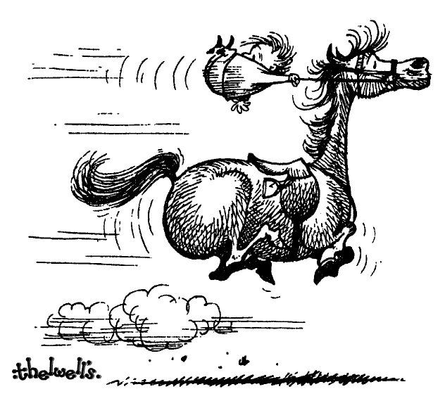

“Get up and Go”!!

Happy Birthday to the following people: -

1st – Murray Evans

3rd – Hayley Horne

7th – Anthony Ward

7th – Dick Wheeler

7th – Murray Chapman

8th – Helene Steenkamp

9th – John Mansfield

9th – James Hackland

10th – Morriagan Halkett

11th – Emma Anderson

12th – Pierre Prinsloo

14th – Megan Hatch

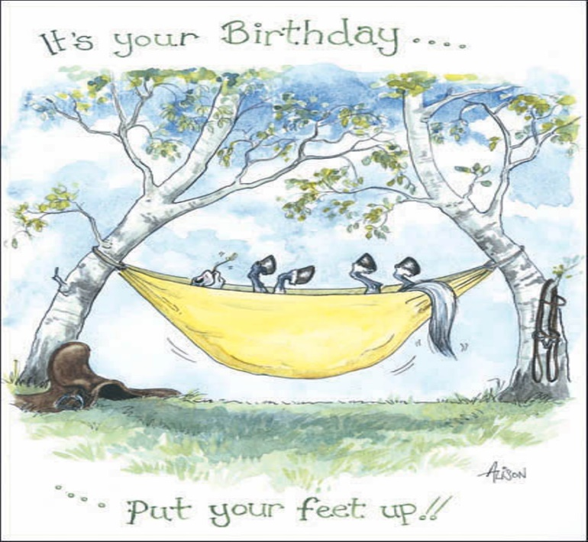

15th – Brya Gillespie

17th – Natalie Maclarty

18th – Stefan Harris

18th – Andrew Evans

19th – Thebea Schuch

19th – Melody Fitch

20th – Thilanie Groenewald

23rd – Michelle Roods

24th – George Schabort

26th – Ethan Gourley

27th – Bradley Bekker

28th – Juliette Guse

31st – Hunter Russel

From the Umpire’s Whistle: -

PLEASE NOTE: - Gavin Flowers will be holding Umpire Clinics: -

: -



13th January – PE

20th January – WP Unicorns

27th January – Bishopstowe

I hope your Club secretaries have updated you all.

Just a reminder to all: -

Please get your SAEF affiliations done asap, their offices will open on the 8th of January should you need any assistance!



Another reminder of the PASA fees for this up coming season and another copy of the fixture list just in case!!

**FEES 2018**

U19 – VETS R950

U16-U18 R800



U12-U14 R400

TRANSFORMATION R300

SOCIAL/TECHNICAL R425

TEMP TOURNAMENT FEE IS R400 PER TOURNAMENT FOR 2 SOCIAL TOURNAMENTS PER YEAR.

YOU HAVE TO BE FULLY AFFILIATED TO PLAY IN THE FOLLOWING TOURNAMENTS:

IPT

SA CHAMPS

ANY INTERNATIONAL

ANY HIGH GOAL OR CLASSIC

PROVINCIAL CHAMPS

**FIXTURES 2018**

