
The ninth chukka
April 2016

CONTENTS: CONTACT US:
Umpire Whistle pasa@futurenet.co.za
Umpire report Easter
Umpire report Bethal
Junior classic 2016
Junior International teams 2016
From the sidelines
Equine hydration
Birthday Wishes
Horses for Sale

BELIEVE
In yourself
Have faith
In your abilities!
Without a humble but reasonable
Confidence
You cannot be successful or happy

- Norman Vincent Peale

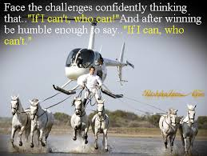
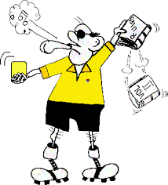 UMPIRE’S WHISTLE

Hi All.
Well Bethal, Easter and junior classic, have come and gone- with lots to share in umpiring views.
Well done to provincial umpires Debbie Dick, and Julian Muller for outstanding work done at these tournaments.
It is great to see, dedication, perseverance and rules being addressed in the provinces.

However, all is never rosy-
Umpire calls by some, were questionable- here are a couple of mistakes we need to watch for.

A penalty 1, is from the spot- not taken to the next penalty line- ( unless player warned before and not listening, so a harsher penalty issued.

A 10 m throw, is exactly that- so please ensure you know how far 10m is, you will be amazed.

Numbers on player shirts, especially on the back, is a rule and has penalties accredited to it, so why are we not doing this.

A surcingle on a saddle, is a safety piece of equipment ( rule 22 e), so please ensure you are doing this.

A player with the ball, may not just cut in front of other players, by changing direction as and when, dangerous riding can cause a bad accidents- in many death to the horse and permanent damage to players.

Horses cannot just be changed as and when- please read Debbies report- there are rules that have to be adhered to.

Warning

Horse welfare officers in polocrosse, are up and running, doing a fantastic job- so ensure you are legal !!!!!!!!!!

Well done to Debbie and Julian for their reports which are in April newsletter.

I will be at the Windpompfees tournament- look forward to seeing you all there.

Cheers and enjoy great polocrosse.

Gav Flowers.

EASTER TOURNAMENT REPORT

The tournament went well. Umpiring standard was good and a firm control of each game was shown by all umpires.

We have had complaints on the alleged misuse of the 1 horse per game, multiple horse per tournament, rule. A horse was retired from the first game on Saturday from fatigue and then brought back to play that afternoon. The tournament committee were asked and from the tournament committee there are two different viewpoints. One person said they could play in the afternoon and the other said he said it could not according to the rule. I do not feel that this is a severe offense at a friendly, first tournament of the year. As a horse owner it is often difficult to get a young horse into the game and from all witnesses the young horse was exhausted during the first game. It would have been extremely cruel to force the horse to continue. Obviously the game in the afternoon was easier and the horse coped with all three chukkas. They were not competing to win but for the best interest of polocrosse and bringing horses into the game I do not wish to make a big deal of this. I went to see the horse before it played on Sunday and it was hydrated and looked within its fitness and competency levels. Judging from the different opinions within the Tegwaans tournament committee I did not follow this matter up further as the rider did consult with the tournament committee, was open and transparent, and did follow the tournament committee’s rules.

I now can see two opinions into the abuse of people withdrawing horses from games through fatigue. I am trying to gather the score sheets from Tegwaans as there is much valued information from the questions at the back of the score sheet which I wish to gather and keep as a data base. This information will allow me to see which rider has horses taken off, misusing spurs or whips and therefore allows me to track the behaviour of riders too. There is a twofold issue here. One is, are horses adequately prepared for tournament with fitness, and 2 are they been ridden too hard by the same riders who are not conserving their horses in a game? A person who has ridden their horse conservatively during a game should not have to now compete against a player who has ridden one horse into the ground and then climb onto a fresh horse. So my gathering of information from those score sheets is to try create a data base of players AND horses. It is concerning me that the questions at the back of the score sheets are NOT being followed up and I would like to request that all people umpiring take the time to complete the form. I only after the weekend had a chance to look at the back and know that I have never been asked by the table to complete as an umpire after the game.

I did not have a good response to the request for passports. Only Hilton and Tegwaans complied. I have requested from Ashleigh Shaw to get a list of each club’s horse welfare officer’s name and details to ask for them to assist in getting passports, names and vaccination history’s to me. I only have 3 welfare officer’s details. This gathering of information is going to take time and effort but one which I feel strongly about. All other horse sports are rigid with the presentation of passports and vaccination history and there is NO reason why we cannot be the same.

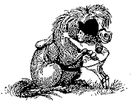

Bethal Tournament Report 2016

The Bethal tournament was held from 12-13 March on a very nice summer weekend, the rain clouds stayed away and we were able to play all the games.

The tournament was tightly contested as we limited the sections to a total handicap of 12. The A Division had 8 sections, B division 4 sections, C division 4 sections, D division 4 sections.

Bethal Polocrosse club had 10 sections in the tournament and 7 players played their first tournament.

The umpire duties were tough to sort ou,t as a lot of players was doubling up from various clubs. We had no serious incidents during the weekend, two players did take a tumble but was cleared by the medics and carried on playing in there respective games.

We also did not have any disciplinary problems that needed to be reported.

Results

A Div - Winners - Bethal C
A Div - Runner Up - Bethal A
B Div - Winners - Kentucky B
B Div - Runner Up - Walkerville A
C Div - Winners - Walkerville B
C Div - Runner Up - Limpopo C
D Div - Winners - Kentucky C
D Div - Runner Up - Bethal H
Most Valuable Player
A Division - Rudi Vorster
B Division - Ben Cilliers
C Division - Telanie Groenwald
D Division - Keegan Staniland
Regards

Julian

!

REPORT BACK ON JUNIOR CLASSIC
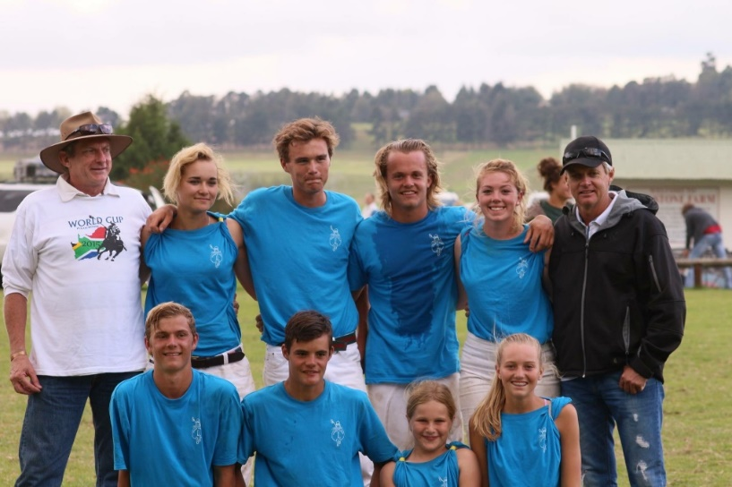
Team Russell James Inc the A Section championship Winners – Coach Henry Harris
This past weekend we had a five days spent with 96 of our South African Junior Players ranging from the age of 6 to 21 years of age. We had two full coaching days which included seven different stations of the following; Horsemanship & Riding Skills, Stick work and tricks, Lineouts and Box work, Penalties and free throws, Netball, Bandaging, Tack and Horse prep. The kids got to spend 1½ hours with each station and rotated on these first two days and ended off their sessions on Thursday afternoon with their National Umpire Gavin Flowers on a session on Umpiring/Umpires.
Then on Thursday evening we had an informative talk from Debbie Dick from Epol on Horse Nutrition followed by the announcement of teams and their coaches and handing out of their sponsored kit. There juniors were broken up into 3 divisions, namely the A sections, B Sections and Future Stars. These teams were put together with equal handicaps which provided a level playing field and opportunity for all teams to have a chance at improving and winning at least one game.
This showed greatly on our score sheets, which were pretty close on the three playing days from Friday through to Sunday.
We wish to thank the sponsors that assisted greatly with the putting together of this very successful tournament and
look forward to the 2017 Junior Classic.

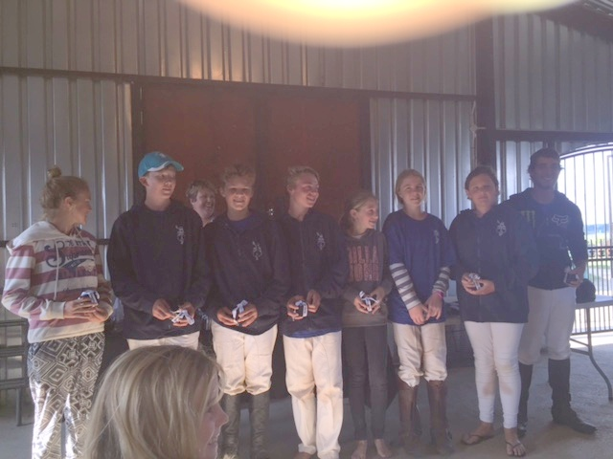
Team East Coast Medical the B Section Championship Winners – Coach Jarryd Jacklin

On Sunday following the prize-giving our PASA President – Mr Hannes Van Aswegen announced the Junior Sides for our upcoming internationals, the teams are below;
U21
Coach – Henry Harris
Assistant Coach – Andrew Heynes
Amber Pretorius Ross Beukes
Jacqui Minnaar Ross Odell
Natalie Maclarty Shane Mansfield
Taylor Mansfield Stefan Harris
U16
Coach – Jan Albert Steenkamp
Assistant Coach – Andrew Heynes
Clio Strydom Chad Von Benecke
Kayleigh Van Wyk Conor Beukes
Paige Pretorius Jens Bunge
Sam Gilson Kenan Claasen

U14
Coach – Luke Rauch

Ishvan Schuch
Jake Shaw
Joshua Le Roux
Micha Van Coller
Robert Anderson
Tayla Von Benecke
Trent Cocker

We wish these junior all the best for the tests and trust they will do South Africa proud!
***************************************

Hi Andrew and Sam

Thanks so much for a brilliant weekend (week for you!) It was such a pleasure to see everyone having a chance instead of one particular team just annihilating everyone else. The fact that there were so many sudden deaths was confirmation of how balanced the teams were – WELL DONE!

From the sidelines …..

Hot Property

It’s always nice when someone in or connected to polocrosse, “cracks” it in the “horse world”. Lyle Hewitson, the son of Sam Harris, now playing polocrosse at Shongweni, with husband Henry, recently featured in the “The Mercury” of Thursday, March 10.

I quote: “Lyle Hewitson is probably the most experienced four – claiming apprentice in the history of the South African Jockey Academy. The champion work rider is “hot property.”

His is a very unusual case, in that his mother Sam, insisted that he matriculate at a “good” school. Nearby Kearsney was the choice, where the headmaster bent the rules so that Lyle could attend sufficient classes to matriculate there, whilst also attending the Jockey Academy, which I know insists on an exceptionally high work rate. Lyle’s propensity for work and dedication to the job is unquestionable!

Regards,

R. Hagen

PS: the Kearsney headmaster speaks very highly of Lyle, saying that with his talent he would have liked him to have taken more time participating in school activities, but that the boy’s heart was in race riding, so that took precedence.
Incidentally in his first teaching job at Pretoria Boys High the current Kearsney headmaster taught Elon Musk!

We consulted two equine nutritionists to answer your burning questions about equine hydration.
Water is the fuel that keeps all living creatures’ bodies functioning. In horses, it’s a crucial nutrient for digestion and thermoregulation, among other life-supporting functions. However, there’s more to keeping horses hydrated than simply providing them constant access to clean water. In this article we’ve called on Kristen M. Janicki, MS, PAS, an equine nutritionist based in Nicholasville, Kentucky, and Mary Beth Gordon, PhD, an equine nutritionist and director of equine research at Purina Animal Nutrition, to answer your most frequently asked reader questions about hydration. In no particular order, here’s (almost) everything you need to know about watering horses:
- How long is too long for a horse to go without water?

Although horses’ bodies can tolerate a lack of water for extended periods, dehydration from water restriction can quickly become fatal. Janicki recommends seeking veterinary help if it’s obvious (based on clinical signs mentioned in No. 5, along with untouched water sources) a horse hasn’t been drinking for two days. “After three to four days, the horse’s organs will begin to shut down, which can result in irreversible (organ and tissue) damage,” she explains.
Water intake, however, is not just about drinking. “Horses on pasture (which has a high percentage of moisture) will sometimes drink little to no additional water,” Gordon explains. “The more dry feedstuffs fed to the horse (such as hay), the more water they will drink.”
She adds that horses also naturally generate “metabolic” water as a result of breaking down protein, carbohydrates, and fat. “This does not provide a large amount of water, but does contribute to the horse’s daily balance,” she says. “All of these things may change the horse’s demand for water. Always follow good basic horse keeping rules and have fresh, potable water available at all times.”

2. How do I encourage my horse to drink?
Both of our sources agree that the easiest way to encourage drinking is to provide your horse with fresh, clean, palatable water at all times. “Frequently checking, scrubbing, and refilling water troughs and buckets is part of the nitty-gritty of horse keeping,” Gordon says.
Other ways to up your horse’s intake include soaking hay and providing salt via salt blocks, loose salt top-dressing on feed, or a salt supplement. “Correct sodium balance in the horse is necessary for proper thirst response and body water equilibrium,” Gordon explains.

3. What temperature water do horses prefer to drink?

There is evidence that horses prefer lukewarm (20°C or 68°F) water, especially during cold weather, Janicki says. For instance, researchers have shown that pony stallions drank 38-41% less water when it was near frozen compared to when it was 66°F. Yet, when kept indoors at warm temperatures, they drank the same amount of both 32°F water and 66°F water.

4. Can a horse drink too much water?
A horse can, in fact, drink too much water, particularly if he suffers from certain health conditions, such as equine Cushing’s disease. Such ailments can cause a horse to exhibit polydipsia, or excessive drinking behavior.
“Excessive water intake can cause stress on the kidneys as they eliminate the excess water and can also dilute the electrolytes in the horse’s body, decreasing its ability to regulate temperature,” Janicki explains.
Healthy horses, however, typically don’t drink beyond their body’s capacity, says Gordon: “In research we conducted looking at water intake from adding sodium to diets, no horse drank beyond what was considered normal for their body weight or based on weather conditions. We’re usually more concerned about the opposite: horses not drinking enough water.”

5. What are signs of dehydration, and what do I do if my horse becomes dehydrated?
Becoming familiar with your horse’s normal vital signs (TheHorse.com/EquineHealthSigns) is one way you can prepare to detect dehydration. Clinical signs include an elevated heart rate or pulse (28-40 beats per minute is normal for an adult horse), changes in gum color and feel (bubblegum pink and moist are normal), and decreased skin elasticity (detectable via a skin pinch test, in which the skin along the neck in front of the shoulder should retract back to normal in less than two seconds when pinched and released). According to the American Association of Equine Practitioners (AAEP), changes to these vital signs occur when the horse is 4-6% dehydrated. Horses typically display visual signs such as sunken eyes and a tucked-up appearance to the abdomen when dehydration levels approach 8-10%.
“Most of the time, dehydration can be fixed by offering clean, palatable water,” Janicki says. “In cases where the horse is 8-10% dehydrated, you will need to call a veterinarian to administer fluids.”

6. On a very hot day, how long would it take for a horse to become dehydrated?
“An idle horse requires approximately 5 L water/100 kg body weight,” Janicki says. “Typically, for a 1,100-pound horse, that would be around 25 L (6.6 gallons) of water per day. This is based on research done on horses kept at a thermoneutral temperature range (-15-10°C or 5-50°F), which is considered to be the temperature a horse maintains its own body temperature with little or no energy expenditure.” How long it takes for a horse to become dehydrated depends on many individual factors affecting hydration status in hot weather, such as diet, work, pregnancy, lactation, and age.
The good news is that in two studies Gordon and colleagues performed recently, they saw a positive link between ambient temperature and water intake. “If temperatures are rising, horses will drink more water to maintain hydration status and offset sweat losses,” she explains. “Therefore, (how long it takes for a horse to become dehydrated) partially depends on the availability of water for horses to rehydrate on a very hot summer day.” In another study, Geor et al. demonstrated that horses exercised at high temperatures (33-35°C or 91-95°F) and high humidity (80-85%) increased their water intake 79% for four hours.

7. Can certain health conditions impact a horse’s water intake?
Basically, any health condition that decreases feed intake can also lessen water intake, says Gordon. And if a horse suffers from diarrhea for any reason, he can become dehydrated easily, even if drinking normal amounts of water, says Janicki.
On the other end of the drinking spectrum, “horses with uncontrolled glucose/insulin may drink and urinate more,” Gordon says. And, as mentioned, horses with Cushing’s disease can develop polydipsia.
Diet can also affect water consumption. “High levels of fiber (hay), salt, potassium, and protein in the diet can cause excessive water intake,” Janicki notes.

8. How can I keep my horses hydrated while competing or traveling?
Janicki suggests making frequent stops (every two to three hours) to offer your horse water when traveling. This will help him not only stay hydrated but also tolerate traveling for long periods of time. Gordon says owners can also offer their horses soaked hay or a compressed hay product: “It masks the taste of ‘foreign’ water and helps ensure the horse remains hydrated.” During competitions or trail rides, offer your horse water whenever possible. “(Horses) should be able to drink as much as they want, unless certain medical conditions prevent this from happening,” Janicki advises. In such cases, work with your veterinarian to determine how much water to offer and how frequently.

9. Immediately after an intense workout, should I taper my horses’ water intake or should I allow them to drink all they want, all at once?
Similar to the response to the previous question, a horse should be allowed to drink as much as he wants anytime after performing an intense exercise bout. Although some owners have reservations about giving a horse free access to water before he “cools down,” Gordon points out that Schott et al. have demonstrated in research studies that horses do not drink beyond their stomach capacity in the first few minutes following intense exercise.
“Water does not need to be withheld,” she says. “Use ambient temperature or ‘hose-cold’ water, and train horses to drink salt water after intense exercise to help replenish water and electrolyte requirements. Also provide clean water at the same time.”

10. Why are some horses so picky about their water sources?
Horses are very sensitive to the smell and taste of water and feedstuffs, says Gordon, and there can be many explanations as to why a horse refuses to drink from a certain water source. Janicki explains that water sources have varying pH levels and, more importantly, total dissolved solid (TDS) levels. “Palatability is affected most by TDS values, which measure the amount of ions in the water source,” she says.
Water hardness (which can be due to high calcium, magnesium, sodium, and potassium levels) also affects palatability. If your horse turns up his nose at water when traveling or competing, Janicki suggests taking water from home with you and making it available so your horse will not become dehydrated.

11. I often ride in the desert where there are no water sources. How long and hard can I ride my horse before he needs a chance to drink?
Our sources do not suggest taking long, hard rides in the desert without water sources, unless you’re completing an endurance event. “Endurance riders typically provide water at all times before the ride,” Janicki says. “Soaking hay or hay cubes before the ride will help with fluid balance. Do not provide grain within four hours of (before) the ride, as this may dehydrate a horse quicker. Offering electrolytes before and after the ride in water will help with electrolyte losses and fluid intake.”

12. When trail riding, what kind of natural water sources are safe for horses? What are the signs that a natural water source might not be safe?
Again, clean, fresh water is the best water for horses. Janicki suggests examining a potential water source carefully before allowing your horse to drink from it, considering its clarity (rainfall and runoff decrease clarity), odor (which can indicate unclean water, potentially impacting palatability), temperature (since extremely cold or warm water affects palatability), and color (which does not necessarily affect water quality, so use this factor in combination with the others—i.e., don’t let your horse drink from mirky, moldy-smelling water that is also green).

Take-Home Message
The best way to ensure your horse is well-hydrated is to offer him free-choice access to clean, quality water regardless of whether he’s stabled, turned out, traveling, or competing. Watch for signs of dehydration, and work with your veterinarian to solve any watering hole issues your horse might have.

About the Author
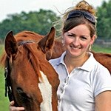

Alexandra Beckstett, The Horse Managing Editor
Alexandra Beckstett, Managing Editor of The Horse and a native of Houston, Texas, is a lifelong horse owner who has shown successfully on the national hunter/jumper circuit and dabbled in hunter breeding. After graduating from Duke University, she joined Blood-Horse Publications as Assistant Editor of its book division, Eclipse Press, before joining The Horse.


April

2 - Christine Jacobs
3 - Brad Kent
4 - Nikita Gilks
5 - Anja Von Wielligh
- Andrew Odell
13 - Heinz Bunge
- Rebecca Coetzee
15 - Paul Davison
18 - Jamin Schuch
- Sean Gilson
19 - Bernice Bentley
20 - Rachel Dolbey
22 - Dean Tessendorf
- Andrew Orchison
25 - Abbey Hackland
26 - Cha Davis
28 - Rochelle Thornhill

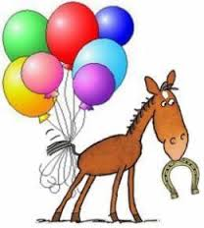

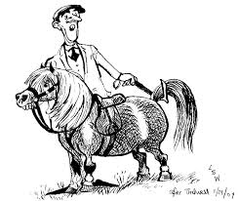

HORSES, etc

TB gelding for sale, has played polo and polocrosse. Loads easily. Contact Michelle Withoft 0844157448

Kilmore Saddle for sale: Langdon Taylor 0834110794

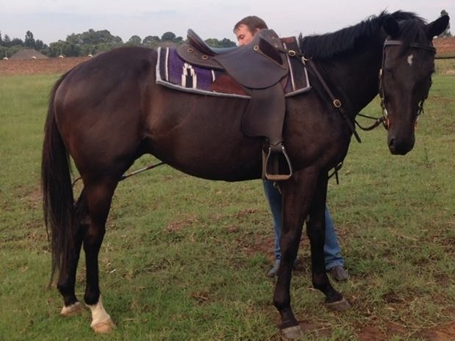

For Sale
Super safe 1st or 2nd Pony for sale
Lovely all-rounder
Name: Merlin Height: 14.1hh
Age: 10 Breed: Mixed

Successfully competing in: Show Jumping (80cm); Working Riding and Equitation
Recently started playing Polocrosse, does some Dressage and would Event.

Boxes easily, stands for farrier and vaccinations, can live out, currently barefoot.
Uncomplicated, easy, confidence-giver for a young child wanting to try everything.
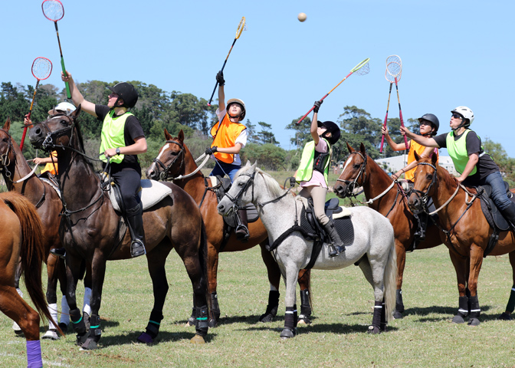
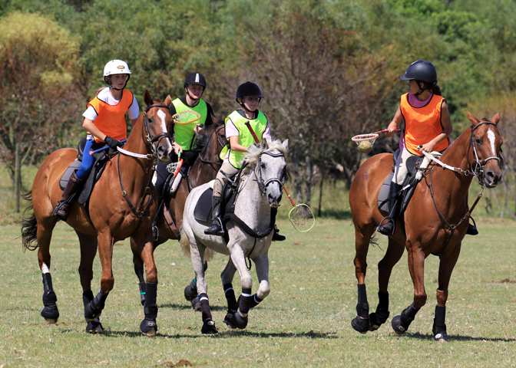
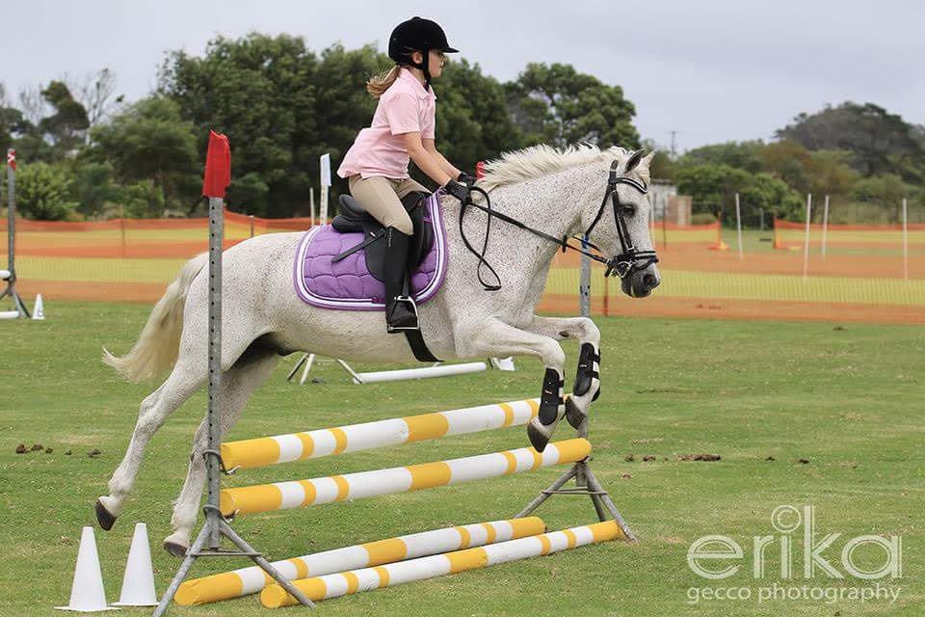
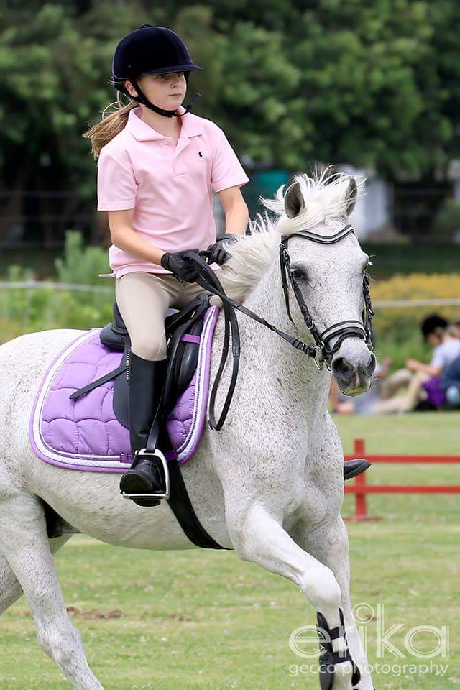
Current Owner has sadly outgrown him

Contact: Karen Boezio at k.boezio@siyayaec.co.za

