
The ninth chukka
December 2016

CONTENTS: CONTACT US:
Umpire Whistle pasa@futurenet.co.za
Fees for 2017
In the Line of Duty
East London development
Birthday Wishes
Horses for Sale
A HORSE(WO)MAN’S CHRISTMAS by horse trainer Doris Eraldi 
It’s the night before Christmas, we’re out in the barn
Blanketing horses to keep them all warm
They’re eating their dinners, tucked in cozy stalls
Not aware that it’s Christmas or any special day at all
They can dream of spring pastures from their pine-scented beds
No visions of sugarplums dance in their heads
But we people are thinking of merry parties and such
Maybe feeling a little sad at missing so much
This season is special but the horses don’t know
We’ve got work to do before we can go
We finish the chores and head on inside
To get ready for dinner and our own yuletide
It’s nearly midnight, the carols are sung
I remember a story I was told when I was young
How at midnight on Christmas Eve
The creatures of the barnyard can speak to us with ease
I am called to the barn, I wade through the rain
I know I must go, I can’t really explain
I slide open the door, pause for a while
Then slowly walk down that dully lit aisle
A nicker from Casey, a wink from JD
Sleepy old Alibi waking to see
Tucker rustling his bedding, a snort soft and light
Each horse gave a greeting as I walked through the night
I thought about parties bright lit and warm
The ones we don’t go to ’cause we have the barn
And vacations and holidays that we don’t get
When we’re working long hours for bills to be met
Walking all the way to the end of the aisle
I stop to stroke Bonnie, it brings me a smile
She snuffles my face, hot breath on my skin
It starts me to thinking about my horses, my kin
I could be at parties with laughter and mirth
But where I am right now is the best place on Earth.

 UMPIRE’S WHISTLE

Hello everyone.

Herewith some umpire information following the executive meeting on 5/6 November 2016.

UMPIRE CLINIC- WALKERVILLLE 11/12 FEBRUARY 2017- ALL PROVINCIAL UMPIRES, ++++ ANY CLUB UMPIRES AND INTERESTED PLAYERS.
( MORE INFORMATION WILL BE SUPPLIED – WATCH THIS SPACE!!!!!!!!!!!!!)

OTHER NEWS.

- It was noted how efficient WP (Cape Classic Tournaments in October), ran these tournaments. Both tournaments, a dedicated person sent via whatsup messages to all involved (including me sitting in KZN), of every game, time, field, umpire allocation, table duty, umpire pony name( owner), stable or pen allocations, important committee names and phone numbers and other important information for every day of these tournaments- at least a week in advance information was out on whatsup with every information needed for a player, participating. Well done WP.

- NW classic in September provided umpires horses for games- another excellent process making participants transporting horses, not having to always have an umpires pony for their game. A dedicated committee member was always on hand to assist with issues that needed attention. Proximity of the 2 fields, and close accommodation made this a great tournament, venue and a fantastic future ahead, as numbers are limited to participate- sponsors were fantastic , helping their teams, and getting involved. Future night games are on the cards- so start preparing for 2017- well done NW.

- RULE BOOKS are almost ready, final editing has been done, photographs, information for players, umpires, coaches and spectators are all in- plus decisive umpire hand signals and much, much more- thanks must go to Hilton Polocrosse club and Kentucky Polocrosse club for their tireless efforts in getting us these BRAND NEW LOOK RULE BOOKS.

- SPURS AND CROPS- a very sensitive but has to be done subject- it was noted, and a directive has been sent out to all clubs, provincial- horse welfare officers, to take a very firm standing on abuse with these 2 aids- it is NOT the crop or spur –IT IS THE PLAYER who abuses the aid- We have had a directive from our Chief Welfare officer- to look at banning these aids. For the time being, until finality has taken its course, any player who abuses a horse with a spur or crop, will have them taken away- not until next game- taken away totally, and handed to the relative provincial horse welfare officer, who will act accordingly, as well as address the player in question. We are being monitored by SPCA, so take this very -very seriously- and rather ask for assistance if you are not sure how to correctly use these aids. Umpires will as per normal make 100% sure in every game, that these aids are correct and being used correctly.

- TMO- well as you all know in rugby, cricket and other sports, this TMO works well. We used it on the final day at Junior internationals in PE, and I have been tasked to continue to look into this, as it will assist our umpires and referee’s in big games or internationals in SA. It can also be used at IPT or SA champs, where the tournament committee deems necessary.

- Lastly- THANK YOU TO EVERYONE WHO DID AN UMPIRE DUTY IN 2016- IT WAS GREAT TO HEAR AT EXECUTIVE LEVEL, THAT AN INCREASE IN GOOD UMPIRING HAS HAPPENED- WELL DONE ALL.

Best wishes to you and your families for a fantastic Christmas, as well as a festive new year- BUT do not forget your ponies.

Gav Flowers.

AFFILIATION FEES FOR 2017
All SAEF and AHS fees are to be paid directly to SAEF via their online payment and registration system. Players will only be paying their PASA fees to PASA via their club and province.
Club secretaries to ensure that birthdates and age groups are correct when submitting affiliation forms to their provincial secretaries. Age group determined by age on the 1st of January.
SNR/VET R720
U21/U19 R720
U18/U16 R590
U14/U12 R150
DEVELOPMENT R275
SOCIAL/TECH R385
TEMP R300 FOR 2 SOCIAL TOURNAMENTS PER TOURNAMENT AND SIGN
AN INDEMNITY FORM
SAEF SNR R300 Once SAEF fee is paid you will get a registration number
SAEF JNR R210

IN THE LINE OF DUTY ……
FEDWEENA by Royal Thunder out of Lustrous Lady 14.11.1998 – 8.8.2015
written by Ashleigh Shaw

I had been looking at getting a young horse in, for myself for a couple of months, when I got a phone call from my sister, Nikki, saying she had found a young mare, quite plain and ordinary looking, but was sure it would suite me and the bonus was that it had the same sire as her main horse at the time, Milkmaid. So I agreed as I knew what an outstanding and talented horse Milkmaid was. I asked her what this mare’s name was and she said it was Fedweena. Odd name for a horse I thought at the time, not knowing what a force this fairy named horse would become.
So I arrived in Pietermaritzburg a short time after Fedweena had arrived at my dad’s house in Bishopstowe, and the first thought that went through my mind was “Nikki, what have you sent me? That little thing will never carry me (and I am not the heaviest person around)” This razor blade of a horse came up to me, and all I could think was, well I hope it’s going to grow, cause it’s got a long way to go. So we loaded her up and off we went back to Kwambonambi. At the time I was playing for East Coast Polocrosse club based in Richards Bay.
A year full of broken bones and gunshot wounds on my side, and paddock injuries meant I missed most of Fedweena’s first year, which might have not been such a bad thing as she was just a 3 year old, but I was determined that by the end of the season she should have played at least one practice. When we were both mended, it was time for schooling. I had one idea and she had another on how to tackle this task. Conventional schooling was not for her, so it was time to think out the box and school without schooling. The end of the season was drawing near and so was my deadline to get this horse on the field.
Last practice of the season arrived and so did I with my new horse. I said I would fill in as a 2 for the first chukka, with the hope of just staying on and seeing how things unfolded as we went. Once again, we had different plans. As the ball came into the lineout, it was deflected onto my side, so as I followed the path of the ball, so did the horse, she came out the line out so fast that I first to reach it. So I picked it up and off we went. This horse was amazing, she had us all totally stumped at her eagerness to just get on with the job at hand.
The following season, she came back and just played as a 4 year old. No questions asked, no task to big. At Estcourt, Nikki came down to play in a tournament there, and I took her to Fedweena’s stable to see how she had filled out. Her first comment was “well, she grew a bit, didn’t she”
This was the beginning of a partnership that spanned over 14 years. As one of the fastest horses on the polocrosse field at the time, I played predominantly in the 3 position on her. Owen Holland passed a comment the one day of how he loved to watch me just ‘reel’ the number one’s in, especially when they thought they had made the break. I often ended up playing against Nikki at IPT or any other tournament we both happened to be playing at, and she said she would get away from most horses but knew there was one that would always catch her.
When Schae, my eldest daughter, had to play Fedweena at a tournament for the first time, she was petrified and convinced the horse hated her. Just getting onto the field proved to be a test, with Fedweena spinning and slamming on the brakes and going backwards. It took a lot of convincing on my part, telling Schae that Fedweena didn’t hate her, she was just testing her. Just to get onto the field and it would all be ok. And that’s exactly what happened. As soon as they stepped over the side line, Fedweena settled and said “Right little girl, let’s do this thing” Schae won best number 3 at that tournament.
Fedweena and I went onto win many accolades in our partnership over the years. The first one being at the East Coast Dolphin Challenge, where we were awarded, Best Lady Player, Best number 3 and the Aussie Horsemanship Award, which we managed to win the following year as well. We also won Best Lady Player at IPT in 2011 and 2013, Best Horse and rider combination and Best number 3 at IPT. She won Golden Pony and Best number 3 awards at club level.

I was very blessed to have had the opportunity to have had Fedweena come into my life and bring such courage, willingness and trust to my game. When I rode her, I felt nothing was impossible and I could conquer the world. So you can imagine the devastation, when I lost her “in the line of duty” at IPT 2015 in Paddock.
Most of us, have had the privilege of owing and riding some truly great horses, and I encourage everyone to just enjoy and appreciate the time we have with them and to share their stories and sing their praises. After all, they have been loaned to us for a time. But without them, we would not be able to play this great game.
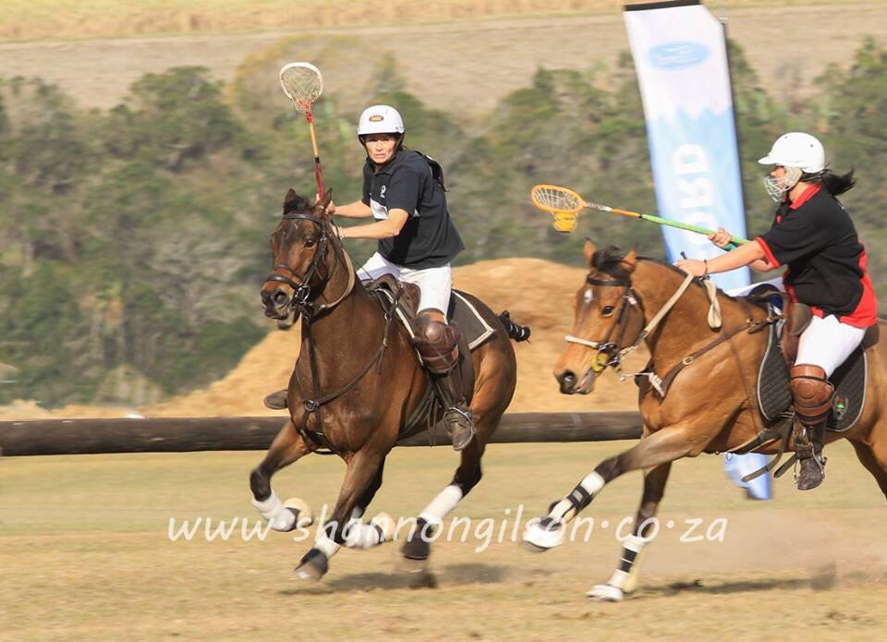

MERRY CHRISTMAS TO ALL POLOCROSSE FAMILIES AND FRIENDS
HAVE A BLESSED CHRISTMAS 

East London polocrosse club - development
Attached are some photos of the East London Polocrosse Club giving a demonstration at the Ambadale Fun Day, Ambadale Riding School is situated near Kidds Beach on the outskirts of East London this was their year-end function in the form of a fun show, where there were children and adults participating in the dressage, show jumping and fancy dress. Most of these children had never seen Polocrosse and the East London Polocrosse club has committed to holding more clinics at the riding school during the next few months.

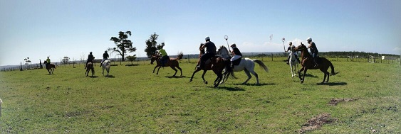

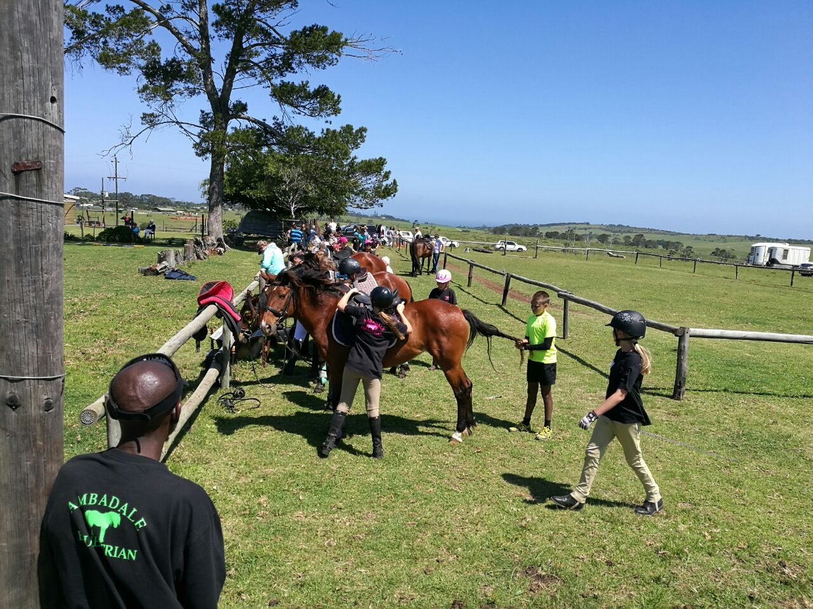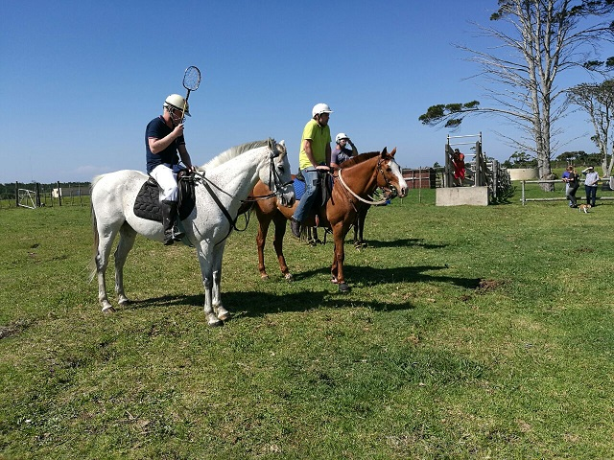



DECEMBER

1 - Connor Beukes
- WW Deysel
- Paula Maclarty
2 - Tayla Von Benecke
3 - Owen Holland
4 - Samantha Hatch
5 - Sarah Dix Peek
6 - James Gardiner
7 - Savannah Sparrow
9 - Nick De Jong
10 - Calyn Angus
11 - Noel Wilson
- Patrick Thorpe
- Nicholas King
14 - Andrew Thompson
- Clio Strydom
15 - Conor McDonald
18 - Stuart Odell
20 - Lance Ridell
21 - Julian Muller
- Chloe Le Roux
22 - Brenda Crawford
- Noel Bauer
25 - Heinrich Fortmann
28 - Kayla Heynes

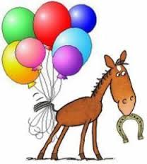

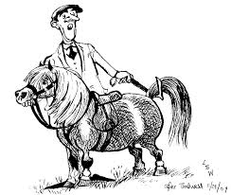

HORSES, etc

Looking for a horse box to lease? Contact Casey Bennett 0769040500

