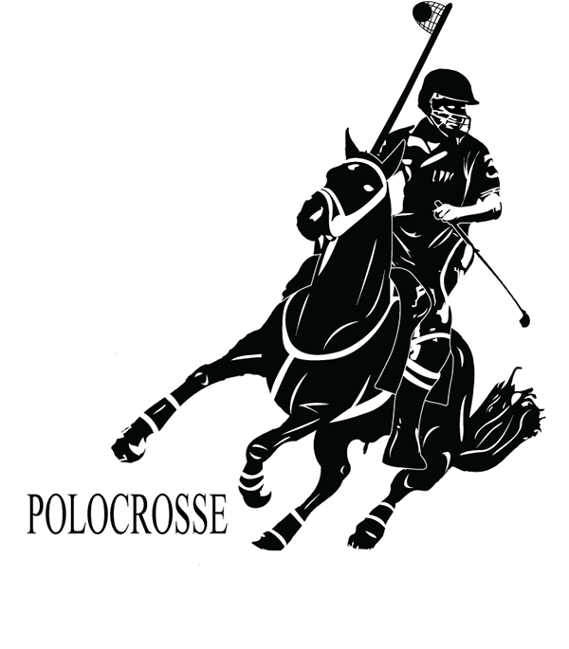
The ninth chukka
December 2017

CONTENTS: CONTACT US:
Umpire Whistle pasa@futurenet.co.za
Fees 2018
Fixture list 2018
Exec portfolio reports
Birthday Wishes
Horses for Sale



Christmas brings family and friends together; it helps us appreciate the love in our lives we can often take for granted. May the true meaning of the holiday season fill your heart and home with many blessings.
On behalf of the PASA executive, we would like to wish all our members, their families and friends a very Blessed Safe Christmas. And we look forward to seeing you all on and around the Polocrosse field in 2018

MERRY CHRISTMAS



UMPIRE’S WHISTLE

Greetings all

I cannot believe we have concluded another year- seems just the other day we were in Australia – April 2017, and the junior internationals were yesterday- wow what a year. Well done all.

There is a portfolio report from the umpiring portfolio for 2018- please read it and ensure you are aware of the process we would like to follow in 2018.

Executive meeting report back November 2017

Confirmed Umpire clinics

- EP at Port Elizabeth- 13/14 January 2018.
WP at Unicorns- 20 January 2018.
KZN at Bishopstowe- 27 January 2018.

Provincial umpires – only KZN and NW confirmed as yet- Debbie Dick and Maverick Gillespie- welcome to another term going forward.
Provincial umpires will continue the process going forward , as by the completion of the umpire clinics in January 2018- all provincial umpires should be suitably qualified to continue the umpiring portfolio in their provinces- this hoping provinces have nominated their provincial umpires wisely, and have attended the umpire clinics as completed.

Internationals- there are some going forward in 2018- yet to be confirmed 100% by the countries- and further advisement on this will follow.

WC 2019- umpire- through a nomination process, suitably qualified international rated SA umpires will be able to apply, together with criteria required- to follow on in 2018 via provincial umpires.
Rule books are still available through the PASA secretary, please contact Ashleigh Shaw or Jo Cocker for information.

An interesting and concise report was presented by the Director of Coaching regarding horses and venues, this was presented in a form of % percentage, and in areas where umpiring needs to be addressed, we will ensure we cover this extensively to ensure rule 6 is adhered to, as well as working in conjunction with horse welfare, horseman ship and coaching in 2018.

Sadly we bid farewell to our present PASA secretary Ashleigh Shaw, who has been a pillar of strength in the assistance of the umpiring portfolio- a partnership that has endured for 9 odd years, through mountains of troubles and oceans of waves, Ashleigh I thank you very, very much.
Thankfully we are not losing Ashleigh, as she is still on the KZN executive committee.
Jo Cocker- welcome to PASA, a sport you have played for many, many, years at international level outside of SA, welcome to SA as your new home- I look forward to working with you, as does the entire umpire panel.

Lastly- a fantastic Christmas and even better new year to everyone-, thank you for your support, from the entire umpire panel portfolio.

Gav Flowers.

FEES 2018
U19 – VETS R950
U16-U18 R800
U12-U14 R400
TRANSFORMATION R300
SOCIAL/TECHNICAL R425
TEMP TOURNAMENT FEE IS R400 PER TOURNAMENT FOR 2 SOCIAL TOURNAMENTS PER YEAR.
YOU HAVE TO BE FULLY AFFILIATED TO PLAY IN THE FOLLOWING TOURNAMENTS:
IPT
SA CHAMPS
ANY INTERNATIONAL
ANY HIGH GOAL OR CLASSIC
PROVINCIAL CHAMPS

FIXTURE LIST 2018
Please note: There is a possibility of an u14/u16 tour in the month of July. We have not been able to confirm this as yet. ALL international tournaments are subject to change on final communications with invited countries.

FEB | Tournament | Venue | Jan 13th Umpire Clinic |  |  | PE
3/4 |  |  | Jan 20th Umpire Clinic |  |  | WP Unicorns
 |  |  | Jan 27th Umpire Clinic |  |  | Bishopstowe
9 | Pasa Exec meeting | Bishopstowe
10/11 | Coach Accreditation Course | Bishopstowe
17/18 | Coach Accreditation Course | Bishopstowe
24/25 | Saints Young horse tournament | Bapsfontein
MARCH
3/4 | George tournament | George
10/11 | Bethal tournament | Bethal
17/18 | Shongweni Green horse | Shongweni
24/25 | PE Autumn Tournament | PE
APRIL
30/31/1 | Tegwaans Easter tournament/U21 Irish/ | Mooi River
 | Vets International tournament | Mooi River
4-8 | Junior Classic tournament | Mooi River
7/8
14/15
21/22 | Bishopstowe Turnabout tournament | Bishopstowe
28/29 | East London Agric Show and tournament | East London
 | MP Champs | Bethal
MAY
5/6
12/13 | GAUTENG CHAMPS
 | Kargs Post | Kargs Post
19/20
26/27 | Lions River sections tournament | Lions River
26 | Inanda chukka champs | Inanda
 | Masters Vet - Zim | Bulawayo
JUNE
2/3 | Saints | Bapsfontein
9/10 | Natal Champs | Mooi River
 | Possible UK side West Auz - TBC
16/17
22/23/24 | Shongweni High Goal | Shongweni
30/1 | EP Champs | TBC
 | Dalareyville
JULY | Possibly U14/u16 tour in the month of July | TBC
7/8
13/14/15 | IPT | Mooi River
21/22
27/28/29 | SA Champs | Mooi River
AUGUST
4/5
11/12 | Paddock/ Snr Irish tour | Paddock
18/19 | Walkerville | Walkerville
25/26 | Shongweni tournament | Shongweni
SEPTEMBER
1/2 | Richmond tournament | Richmond
 | PE Spring tournament | PE
8/9 | NW CLASSIC | Huhudi
15/16
22/23 | Arnot Green horse
29/30 | Cape Classic | TBC
OCT
6/7 | Cape Classic | TBC

Presidents report

We had a hectic year of polocrosse starting with a tour to Australia which South Africa won 3 0 tests for the men and 0 3 unfortunately for the woman,

Natal champs has been the biggest in years with USA and UK playing in tests against SA teams afterwards,
This has re energised our second and 3rd string of players,

Junior classics, Sam Heynes, did a great job with the French and Zambian kids also participating .It was a very successful junior classics and a lot of development took place with our youth,
Thank you to the Timm family for their hard work during all our events at Mooiriver.

U16/U19 Tests against Zambia was a spectical to watch and did we have mixed results in that.

High Goal once again proven to be a big success. Well done to Brent and the Shongweni team. Thank you once again to Land Rover.

IPT was played in good spirit and a very high standard of polocrosse was displayed at Richmond.

U14 tour in Paddock our kids were unfortunately not on the same level as our Zambian opposition.
We do have challenges with our lower ages and this is where we must do a lot of development with new players and schools.

SA Champs in Bethal was badly supported which unfortunately for PASA, was an embarrassment, as we had a very big sponsor TWK, which supports Bethal, that sponsored a lot of very good and big prizes. Thank you to Gert, Irma, Elri and Johan for a fantastic effort,
Congratulations to Bruce Maclarty, who won the I10 Hyhundai that was drawn by the director from TWK live.
Unfortunately we didn’t raise as much funds as we would like to with this fundraiser.

Our world cup team has been selected and they will be primed and prepared the 2018 season to bring us back the world cup. Congratulations to all these players.
Now your work and commitment starts. Please do us proud in 2019.

NW Classic has proven itself as a prestigious event with 13 International players that entered and played in this tournament.
This tournament was also attended by the Irish President. NW Federation President. Sascoc NW President.
High standard of polocrosse was played in the top 3 divisions. Fun and good food was enjoyed by all.

The Cape Classic was a first for me but definitely not the last .Well done to Helene Steenkamp and family and club members
for arranging a top class event .Thank you for your hospitality at the event.

It is with sadness that we say goodbye to Ashleigh Shaw as secretary as she did a fantastic job for the past 8 years for SA Polocrosse.
Welcome to Jo Cocker which is based in JHB as our new PASA secretary and Good Luck with this challenging position.

New elections has taken place which resulted in new provincial Presidents representing their provinces at the executive.
Congratulations and good luck. Welcome back Tony Higgs as Director of coaching.

Congratulations to Brent von Benecke to be appointed as assistant coach for our World cup team.

The last Executive meeting for 2017 was held in Bloemfontein at Tuff Top Turf which could be a future venue for IPT and SA Champs

I would like to thank the Executive for their support and the vision that decisions are taken now in the interest of our beloved sport polocrosse.
A special thank you to Francois 'Toitjie’, our Pasa Vice President for his commitment and support it is highly appreciated.

Thank you to all the parents for all your time effort and money spent on your kids and our future.
Thank you to each and every affiliated player for being part of our organisation and what you do for the sport and your ponies.

I would like to wish everybody a safe and enjoyable festive season

Hannes van Aswegen
Pasa President

Portfolio: Vice President

Well the 2017 season has come to an end and many find themselves looking at each other saying “what shall we do this weekend”. If we take the time to look back I think all will agree that it has been a busy year for polocrosse in SA. With numerous successful International tours and local tournaments during the year. I would also like to take the time to thank all the members on the Executive that have travelled to numerous meetings and have spent many hours behind the scenes in support of our sport.
There are however areas where we do need to strive to improve on during the 2018 season
- Respect for the Umpires and in turn Umpires respecting the players, we will all need to umpire at some stage in our polocrosse career, it isn’t an easy task and we all know that, so let’s not make it more difficult for our fellow players. Address each other with respect and support and in a tone which you would like to be addressed.
- Horse welfare, there has been some incidents where players have been reprimanded on the use and / or abuse of crops and spurs on their horses. I wish to thank all the horse welfare representatives as well as the horse coordinators at the various International tournaments who have done an excellent job in ensuring the welfare of our horses, there has been some valuable growth and improvement. The exposure of our sport is growing in the media and we should therefore ensure that we are exemplary in the way we treat our trusted partners in the game.
- Dress code at functions and at prize giving, please ensure that we are dressed in the correct attire as stipulated within the rules. In addition to the dress code we need to ensure that under-age members are not exposed to alcohol and inappropriate behaviour at our tournaments / functions, this is everyone’s responsibility.
- We need to install discipline and respect within our members when using facilities /premises where tournaments are held or where we attend functions or represent the sport. We are reliant on numerous private and / or club facilities. There have been too many cases where items have been vandalised or facilities were not left in a clean state, this is unacceptable and needs to be eradicated.
- Communication, note that the PASA executive has been appointed by the PASA members and as such are there to support and grow the sport and the players. We urge all members to use the correct lines of communication in order to provide feedback on the good and the bad in order to have matters that need attention addressed.

The 2018 season lies ahead and we urge all players to make sure that their horses receive the necessary vaccinations in the off season, passports are updated and that the horses are given a good rest so they can all be ready for a new year’s exciting polocrosse season. There are some exciting and new ideas for the new season and we plan to grow and expand polocrosse. Thank you for your support throughout the 2017 season and for your continued commitment to keep our discipline and sport at a high standard in order to ensure that Polocrosse grows and that we create a healthy environment for all.

We wish you a merry Christmas, please take care when travelling during the festive season and we will see you in 2018 ready for yet another exiting season.
Best regards
Toit

KZN CHAIRMAN’S REPORT ON OUR VISION OF ACTIVITY FOR KZN POLOCROSSE IN 2018
We as KZN plan 2 big fund raising events to raise funds to:
- Enable as much support for the major tournaments whether they are in or out of KZN.
- Assist where possible for the development and or improvement of our playing surfaces.
We would like to grow:
- Our player numbers and in particular new members.
- New club/clubs
- The number of umpire clinics in KZN, hopefully 3
- The number of KZN coaches to be accredited in the new coaching structure.
- The number of coaching sessions at various KZN clubs
- Ladies development where a ladies only coaching clinic will take place.
We will also initiate our Natal Disciplinary Committee in line with the PASA Executive to enforce our expected code of conduct with appropriate sanctions if they are breached.
My goal is to have an open transparent KZN decision making executive, which serves the interests of the Natal Polocrosse Community, and which will also work to improving our relations with the other Provincial Chairmen on the National Executive, to making decisions which are in the best interests of South African Polocrosse.
Merry Christmas to all Natal players and to the rest of our Polocrosse fraternity!!

Henry Harris – KZN Provincial President

WESTERN PROVINCE PROVINCIAL REPORT – Luke Rauch

The 2017 year has again been a great year for the Western Cape, starting with the early success of the Australian tour and our 2 boys, Jannie and Retief beating Australia, in Australia was a fantastic triumph for SA Polocrosse. A big shout out to Camilla Harris, George Schabort, Jannie Steenkamp, Julia Pilbeam, Luke Rauch, Retief Steenkamp, Stefan Harris, Ross Odell, Amy Dodd and Roland Wilson all attending. Next up was the Quadrangular series with Jannie, Retief, Stefan, Luke all playing for SA A side against UK, USA and SA B and winning all their games! Another successful High Goal, with Jannie being sold as the most expensive wildcard in the new series history and George Schabort, Jannie, Stafan, Retief, Julia and Luke all being invited to play. Following that was IPT, and Western Cape sent up an U14 side, 2 u16 sides, an U19 roving side, a mixed ladies side and a full men’s team. Congratulations are in order for Biana Du Toit, Christian Human, Jeanique Roodman, Roland Wilson, Clio Strydom, Micha Van Coller, Michelle Wiehan, Klari Du Toit, Amy Dodd, Marlette Visagie, Stefan Harris, Retief Steenkamp, Jannie Steenkamp, Luke Rauch, George Schabort and Camilla Harris. Following IPT we saw our home grown talent take on Zambia in the U16 tests with Luke Rauch Coaching and coming home with a 3-0 victory against the rovers. Well done Micha and Clio!

On a separate note a big thank you to our sponsors that have made our new Winelands Cape Classic the success it deserves and to the organisers who have done such great work in such a short amount of time to put this off! Special thanks to Mark Watters of Elite Charters for this title sponsorship, Jaap Engelbrecht for his sponsorship and continued support for the tournament he founded, Peter Choice for his support with regards to horses travelling and Helene Steenkamp for her efforts, use of grounds and for driving this. A special thank you to our National President, Hannes Van Aswegen for making it all the way down to the Cape and for all he has done for our sport in his time as President.

To all the players who have travelled far, we all really appreciate your support and this event would not be the success it is without your continued support.

From the Western Cape have a very Merry Christmas – looking forward to a brilliant 2018 !!

LIMPOPO PROVINCIAL PRESIDENT REPORT

We are very appreciative that two players had been selected in 2017 to represent South Africa in the U/14 and U/16 teams. Without the coaches, as well as everyone else involved, this opportunity would not have been achievable.

As for 2018's Polocrosse calendar it has been decided that more social events will take place than all round full team participation. However some team members will still work hard to participate. Development is one of our top focus points in the year to come, seeing as a lot of new players are showing interest.

We, the Limpopo Crusaders, wish the Polocrosse fraternity a blessed 2018 season.

Kind Regards
Eduard Schuch

Gauteng Polocrosse 2017 – Ross Beukes – Provincial President

2017 has been a great year for Gauteng in many respects. To start, we would like to thank all the players in Gauteng for their effort and support this year. It was great to have so many players come together for the better of polocrosse in both Gauteng and South Africa.
We began the year with a well supported umpires course at Walkerville, where many GP players upped their umpiring knowledge and skills. We saw a wonderful increase in players willing to umpire and seeking advice to improve their ability.
IPT was a major highlight for the province as a whole. We were able to send more teams than have been available for a long time, which demonstrated how the province came together to improve and develop polocrosse. It was a fantastic opportunity for the juniors in the province to gain some exposure and see what they need to work towards – we have some amazing talent in Gauteng and aim to increase their exposure nationally as well as develop skill throughout the age groups. Thanks to everyone who made IPT possible – from drinks sponsorship, to kit, to transport, horses and coaching. What an amazing experience for all involved.
Clubs throughout the province have done a great deal for development this year. We experience an increase in affiliations within clubs, as well as adding to our number of affiliated clubs in GP. Welcome back to Saints Polocrosse Club – it is fantastic to see the black and white shirts on the field again and look forward to supporting you at your tournaments next year. Thank you to every club in the province who put in the effort to increase their player base – we are growing from strength to strength.
We look forward to a successful 2018 – enjoy the off-season.

Karen Odell – INTERNATIONAL LIAISON OFFICER

With the assistance of the Executive and polocrosse members all junior age groups and the seniors had international exposure in 2017.
The Executive would like to continue with this practice in 2018 in addition to the focus on our World Cup preparation.
We have confirmed the following tours -
U21 incoming tour against Ireland in April.
Senior incoming tour against Ireland in August.
We have had a request from Australia and have requests out to the UK for U14 and U16 tours. As soon as there is confirmation on the details they will be communicated to the Polocrosse community.
Peter Choice will be communicating the selection criteria on the confirmed tours in the near future.
There are also plans for tours for the Veterans and Masters players but these plans lie in the capable hands of Nicola Van Aswegen.

Eastern Provnice - President’s Report – John Mansfield

The Eastern Province had a busy 2017 season with some very proud moments featuring.

Kéara Mattheus joined the tour to Australia where she represented the unofficial SA side and gained invaluable experience that has and will stand her in good stead.
June was a very busy month with a number of our EP members selected for many of the fixtures.
Ashley Cooper, Brian Cooper and Shane Mansfield played in the B-sides in the Quadrangular.
Nikki Crook, Tayla Mansfield, Ashley Cooper and Anneli van Jaarsveld were invited to participate in the prestigious Landrover High Goal at Shongweni Club.
EP sent the following 2 teams and 2 sections to IPT:
Sections – U19 & Veterans
Teams - Ladies & Mens Open B who were the runners up in this division. The team consisted of Tim Hayden, Chris Newton, Brian Cooper, Allan Oates (who was unfortunately injured and substituted by Paul Davison), Andrew Orchison and Shane Mansfield.
Tayla Mansfield was selected to play in the U19 team in the Zim/Zam/SA tour.
And for a second year running the PE Polocrosse Club was awarded the trophy for Player Development at SA Champs.
We are proud of each and every achievement.

We’re looking forward to the 2018 season with an Umpire’s clinic already arranged for the 13th & 14th of January, with others in the pipeline too.

NORTHWEST ANNUAL REPORT – Nicola Van Aswegen – Provincial President
2017 has been a good year for polocrosse in our little province. We have experienced a growth in numbers and welcomed 2 new Clubs being Harties and Cammelot .
Brya Gillespie, Mav Gillespie and Craig Buss from Huhudi Club represented the SA B team in the Quadranglar held in Mooi River and Nicola Rae played in the unofficial Invitational Masters Tournament winning Best Horse and Rider in Bulawayo.
IPT was poorly supported with only a ladies section representing North West.
Huhudi Club won the B division at SA Champs and Nicola Rae on Kafupi won the Golden Pony. Wian Botha from Vryburg Club won most Promising Junior.
Huhudi Club hosted their 3rd and most successful North West Classic with 128 riders including 16 players from Ireland, England, Wales and Australia.
Looking forward to 2018!!
Mpumalanga Report 2017 - Elri Van Der Merwe – Provincial President
I can’t believe that we are at the end of 2017 already. In general Mpumalanga had a good year taking in to account that we only consist of one club. Hopefully this will change in 2018.
Hosting SA champs second year in a row was a big honour for our club although we had poor attendance and “slightly” chilly weather. Mpumalanga champs tournament was well attended by all the “Highveld” clubs and unfortunately we were not able to have our club tournament due to rain, although the ladies squad still had a practice that weekend at Bethal and they would have played in the tournament.
Up and coming juniors…. Wow crazy talent, just to mention the 3 players that participated in Junior Classics – Tilanie Groenewald, Rikus Cilliers & Ruben Vorster. Rikus Cilliers also represented the barbarian team at Jnr level.
Thank you for a great polocrosse season, we are looking forward to 2018 and will start with our preparation early next year in order to represent Mpumalanga at IPT level as we had only 2 players attending IPT this year. This will hopefully change in 2018
Have a blessed festive season and see you all next year!
Player Representative Report 2017

The role of player representatives in polocrosse is increasing steadily as the community becomes more aware of the roles and responsibilities involved. As a collective, we are the voice between players and their executive for issues and concerns at all levels within polocrosse in the country.
In conversations held this year, it was clear that majority players are supporting the good of polocrosse and striving to see the sport grow and maintain good standing in the eyes of other players, other sports, external role players and supporters. To me, this is key for the success of any sport both on and off the “field”.
I encourage people to voice their concerns as it lends to healthy conversations that aid improvement and development, albeit through the correct channels. In 2018, the player representative committee aims to be more present in conversations and hopes that this drives positive interaction for the better of polocrosse.

Emma Hall

Junior President Report - 2017 by Karen Cocker

I am privileged to be your new Jnr President. I hope I can fill the shoes of my predecessor – Sam Heynes. I would like to personally thank Sam for all the hard work she put into the position over the past two years.

My thoughts so far for my new role as Jnr President……
The job description is non-existent so I shall just wing it. I have been handed a list of tours the outgoing executive had jotted down for the 2018 season. There have been many phone calls with our International Liaison person, Karen Odell, and with Zambia. It seems that the U14 and U16 tours against Zambia will not be happening. I am not opposed to this as I am sure you will agree that the 2016 and 2017 were very busy years for our Junior members and a financial strain for the every suffering parents!

The Zambian players are very keen to keep up our good relations we have developed over the years. There are Zambian players who are very interested in playing in our Jnr Classic which has been pencilled in for the 5th to the 8th April (Exec will finalise dates at our planning meeting on the 18th November) The Zambian players would like an exchange programme, whereby if you lend them a horse to play in the jnr classic, they will lend you a horse to play in a similar tournament in Zambia in 2019. If you are interested please contact me.

We are in the process of trying to find an under 19 side to play against us. I would like to see our u19 ladies challenged in 2018. They had an easy test match this year. We are looking forward to hosting the Irish u21 side in the Easter holidays. I will let you all know when the selection tournaments will be and what the selection criteria is, once I find out.

I plan to make contact with all my provincial Junior representatives once they have all been selected so that we can work together as a team and keep our juniors interested in Polocrosse.

If you have any ideas or suggestions about how we can improve junior Polocrosse in South Africa or any special events you would like me to add to the Polocrosse calendar, please call me.

Yours in Polocrosse

Karen Cocker
082742305
Email gpcocker@mweb.co.za

CONVENORS OF SELECTORS REPORT

Firstly, I would like to thank both my panels of selectors – Junior and Senior – and commend you on a job well done. It was a tough year with so many tours taking place, and finding the best combination of top players to participate in the various tours and attain success.
I would like to inform all PASA members that there will be a number of tours in the 2018 season, so please look out for the communication from PASA on which tournaments and criteria will be applicable for these upcoming tours.

Wishing you all a very Merry Christmas and an exciting 2018

Peter Choice

Director Of Coaching Report

Well it’s going to be an interesting few years ahead. I’ve been thrown in at the deep end and having been out of the action for the past season or two, there is a heap of catching up to do with regards to our coaching program and future plans.
First off all I would like to congratulate Brent on being given the honour of Assistant Coach at the W/C 2019. I would like to thank Luke, Gavin and Caroline for participating in the process and I am encouraged and grateful to see so much interest in Coaching of our National sides.
As you are all aware we have to register to SAEF who in turn fall under SASCOC, and as such we are obliged to train and register all our coaches by the end of 2018. There is a window of opportunity to register all our coaches who have a Record of Prior Learning, so it is vitally important that we comply before this window closes. After 2018 no one, who is not registered with SASCOC, will be able to coach, locally or internationally.
I applaud those of you that have and are organising coaching clinics. I would just ask that going forward you submit a letter of intent and a curriculum pertaining to your course/clinic, for my records and I will in turn send you a covering letter to formalise the proceedings before you start. On completion please submit an attendance register with a report back with objective achieved. This is vitally important in building a resume`, covering insurance and applying for grants etc.
Going forward we have to get our level 1, 2 and 3 coaching programs up and running. To this end we will run a level 1 on 10/11th February 2018, level 2 in 2019 and level 3 in 2020. All coaches (prospective or otherwise) wanting to complete the Level 1 Coaching Accreditation are welcome to attend.
I wish everyone a great festive season and may you have the best Polocrosse season in 2018 ever.

Yours in Coaching
Tony Higgs

Chief Handicappers report
James Hackland

The 2017 season has in my opinion been one of the most successful in the last few years, with most of the major tournaments being very well attended and some incredible polocrosse played. I feel the internationals we hosted this year have reignited the fire in the polocrosse fraternity once again.
I received good input from most of our Provincial handicappers this year with many changes through the year, particularly the lower ones. We possibly erred in making changes too often in the year and we should tighten up on that in 2018, preferably making three handicap change dates.
There has been a steady rise in handicaps across the board in the last few years with possibly too few handicaps being dropped.
Our goal as handicappers should be to get all fairly evenly handicapped teams playing to a draw. If in the event of big score differences, handicaps need to change.
I’d like to congratulate all our players for a great 2017 and wish them luck for 2018.

Development Officer – Brent Von Benecke
2017 saw a lot of development of all levels in our sport. Starting with the very successful Junior classic tournament held in Mooi River, where a very young and inexperienced U14 side was chosen. But how did these juniors improve and do us proud against the Zambians, maybe not winning this time but putting on a performance to be proud of. Well done to Ross Beukes and Gordon Shaw for the brilliant effort put into these youngsters and stars of the future.
Next was the Senior Quadrangular, where our Seniors had a chance to show off their skills, with the Men’s and Ladies A sides coming out tops. This was a great opportunity for many players who are ‘knocking on the door’ as each team was allocated a very experienced coach and I am sure every player benefitted from this pool of knowledge.
Our U16’s and U19’s took on our Zambian counterparts in Richmond, and some superb polocrosse was played with SA coming out the winners. It was very impressive to see the depth of players that SA Polocrosse has to draw from.
Some exciting news from the Ladysmith area. There is the potential of a new club developing in this part of the province, so we look forward to seeing these new players on the playing field in 2018.

PASA has initiated a new development programme for 2018, each province can apply for a starter pack of sticks and some balls to develop polocrosse in their regions with people that have never played before but would like to ‘give it a go’. Each province will be liable for their starter kit. So these kits can be taken to a venue, the sport demonstrated and they are returned to the province for safe keeping and more demos. We certainly hope the provinces will take advantage of this initiative to develop polocrosse in their regions.

Our Director of Coaching will be holding coaching clinics to develop coaches that already experienced in coaching as well as anyone who feels that they would like to obtain their coaches accreditation level 1. Level 1 will be covered in 2018 and Level 2 and 3 in 2019. This is a requirement from SASCOC for anyone wanting to do coaching. So please feel free to contact Tony Higgs to find out where these clinics will be held.

Merry Christmas!!

PASA SECRETARY REPORT
I would like to thank all the provincial and club secretaries for their ongoing effort to ensure the smooth transfer of communication to their members and to ensure that their provinces are up to date with all the required affiliations etc. This is an ongoing battle for all members in the admin positions, I urge all players to assist their secretaries by getting their information to them timeously.

Thank you to the PASA executive for endeavoring to act in the “BEST INTERESTS OF POLOCROSSE” in the decisions that you take and will continue to do so, thereby ensuring a fair and transparent playing field for all members from A division to Z division.

Lastly, welcome and good luck to Jo, our new PASA secretary. Jo will be taking over shortly, as my term comes to an end on 31st of December 2017.

Merry Christmas and a Safe New Year to all PASA members.

See you on the playing field!!
Ashleigh Shaw
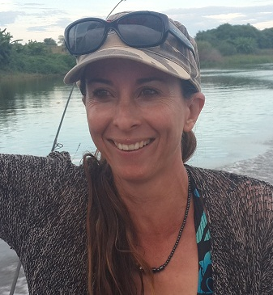 Meet your new secretary - Jo

 BEST BIRTHDAY WISHES ON YOUR BIRTHDAY

December

1 - CONNOR BEUKES
2 - PAULA MACLARTY
4 - SAMANTHA HATCH
5 - SARAH DIX PEEK
10 - CALYN ANGUS
- ROSS HALDANE
11 - NOEL WILSON
- NICHOLAS KING
14 - CLIO STRYDOM
18 - STUART ODELL
19 - NICK DE JONG
- SERGIO MENDES
20 - MANFRED ROHWER
22 - BRENDA CRAWFORD
25 - HEINRICH FORTMANN
28 - KAYLA HEYNES





HORSES, etc

Ladybug, looking for a forever home:
Ladybug is an A-division polocrosse pony, 17 years old, approximately 15.1hh, chestnut mare, unknown breeding, but definitely has thoroughbred in her.
She has been playing polocrosse most of her life and is getting to the stage where she needs to slow down, but still has a good few years of polocrosse left in her.
She will be the ideal polocrosse schoolmaster and suit someone who is already a fairly experienced rider, who would like to either start playing polocrosse or advance their polocrosse skills. Ideally someone who is a 0, 1 or 2 handicap.
Ladybug is an easy horse to keep, does not require shoes, loads and travels well. She had done a bit of jumping as well.

Please contact Hannah on 0785342330 if you are interested.

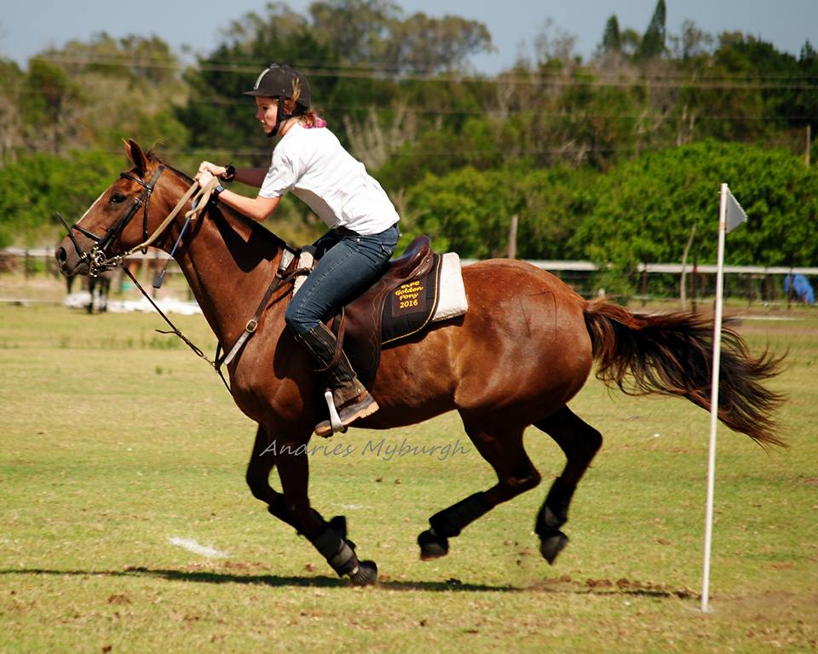

STABLES TO LEASE
Opening in October in Eston. Loads of grazing.
Email : stables2018@gmail.com
