
The ninth chukka
January 2016

CONTENTS: CONTACT US:
Umpire Whistle pasa@futurenet.co.za
Fixture list and fees 2016
Birthday Wishes
Horses for Sale

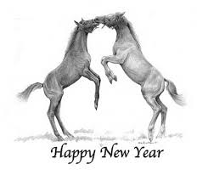

Wishing all pasa members, their families and their beloved horses a safe, prosperous 2016

PASA MISSION STATEMENT

CREATE A TRANSPARENT ENVIROMENT THAT WILL ENCOURAGE DEVELOPMENT AND IMPROVEMENT NATIONALLY, PRODUCING POLOCROSSE THAT WILL SUSTAIN, BUILD AND GROW PLAYERS, CLUBS AND OUR WORLD CUP TITLE

 UMPIRE’S WHISTLE

Happy New Year everyone, I trust everyone had an awesome break and is rearing to go for the 2016 season.
I hope that everyone had a chance to read through their rule book, so that any queries can be discussed at the Umpires meeting, which will be held by all the Provincial Umpires with the Chief Umpire, so that we can make sure we are all in agreement with the rules and how to implement them.

Just a reminder Rule 14(g) states the following

g) Where an umpire is unable to do his/her umpiring duty, it is up to that umpire to arrange a replacement umpire of an equal standard, and notify the Tournament Committee of the replacement- 1 hour before the game.

- It is YOUR responsibility to check when and where you are Umpiring over the weekend
- If you are unable to do this Umpiring YOU need to find a replacement and discuss this with the Tournament Umpire to see if he/she is happy with your replacement.
- The excuse of “I didn’t know” is unacceptable; imagine if it was your game that the umpire did not pitch up for you’d be furious however it seems to be ok to not pitch up for umpire duties??
Please everyone adhere to this rule.

Andrew

**************************************************************
ALL TOURS, TOUR DATES AND TOUR VENUES
ARE SUBJECT TO CHANGE
***************************************************************

TOURNAMENT FIXTURES 2016
DATE | TOURNAMENT | VENUE
JANUARY
FEBRUARY
6/7
13/14
20/21
27/28 | DSC green horse | Shongweni
MARCH
5/6 | Walkerville Chukka Champs | Walkerville
 | Tenikwa Tournament | George
12/13 | Mooi River Start of Season | Mooi River
 | Bethal tournament | Bethal
19/20
25/26/27 | Tegwaans Easter tournament | RICHMOND
APRIL
2/3
9/10 | PEPC Autumn | PE
16/17 | MP champs | Bethal
23/24 | Umvoti | new venue Greytown
30/1/2 | WINDPOMPFEES | Mokgopong/ Nylstroom
 | East London Agric | East London
MAY
7/8 | BISHOPSTOWE | BISHOPSTOWE
 | Vryburg | Delareyville
14/15
21/22 | WP Champs | Saldahna
 | GP Champs | Arnot
 | KARGS POST | Kargs Post
28/29
JUNE
4/5 | Natal Champs | Richmond
11/12 | over 40 tour to Australia | Coolah, Australia
18/19 | over 40 tour to Australia | Sydney, Australia
25/26 | Zambia Open | Livingstone
JULY
1-3 | IPT | PE
9/10
12-17 | Junior festival u16/u19 vs Aus | PE
 | Junior U14 outgoing tour | Zambia
23/24
30/31 | EP Champs | East London
AUGUST
6/7 | Walkerville Turnabout | Walkerville
 | Paddock tournament | Paddock
13/14 | Shongweni High Goal Men & Ladies | Shongweni
20/21
26/27/28 | SA Champs | BETHAL
SEPTEMBER
3/4
10/11 | NORTH WEST CLASSIC | Huhudi
17/18 | PEPC Spring | PE
24/25 | Snoek Tournament | Saldahna
OCTOBER
1/2 | CAPE CLASSIC | Saldahna
6-9 | Junior Classic | Mooi River
15/16
22/23
PASA FEES FOR 2016 (INCLUSIVE OF SAEF FEES)
SNR/VET /U21/U19 R900
U18/U16/U14/U12 R700
U8 FREE
TRANSFORMATION R250
SOCIAL/TECHNICAL R350
MEMBERS TO AFFILIATE THROUGH THEIR CLUBS TO PROVINCE TO PASA, NO DIRECT AFFILIATON TO PASA WILL BE PERMITTED!

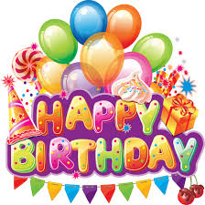

January

1 - Murray Evans
3 - Hayley Horne
7 - Anthony Ward
9 - John Mansfield
- James Hackland
10 - Morrigan Halkett
11 - Emma Anderson
12 - Emily Bristow
14 - Megan Hatch
15 - Brya Gillespie
17 - Natalie Mclarty
18 - Stefan Harris
- Andrew Heynes
19 - Melody Fitch
- Thabea Schuch
24 - George Schabort
27 - Bradley Bekker

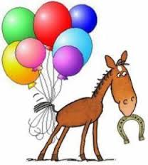
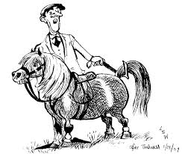

HORSES, etc

.

Allisons Saddlery is going online. The new website will be up and running is a couple of weeks, but if you are looking for any equestrian equipment you can email sales@saddlery.co.za for a quote

PASA WEBSITE www.polocrosse.co.za for all the latest updates.
A big thank you to Karen Cocker for keeping us all informed and maintaining the information on the web page.

