
The ninth chukka
January 2017

CONTENTS: CONTACT US:
Umpire Whistle pasa@futurenet.co.za
Fees for 2017
Fixture list
In the Line of Duty
Birthday Wishes
Horses for Sale



This Bright New Year Is Given Me To Live Each Day,
With Zest To Daily Grow And,
Try To Be My Highest And My Best…!”

HAPPY 2017 EVERYONE!!

UMPIRE’S WHISTLE

GREAT 2017 EVERYONE-
Trust you all had a fantastic Christmas and New Year celebrations, and ready for 2017.

DON’T FORGET THE UMPIRE CLINIC 11/12 FEBRUARY AT WALKERVILLE- all provincial umpires will be there, plus any club umpires or interested parties.

No cost to attend, meals for each person account.

Accommodation- Walkerville will try to accommodate as many as possible (mattresses, beds in local club homes) or if you wish, book your own.
Numbers are required by 25 January 2017- so first come first booked.

FORMAT FOR UMPIRE CLINIC.
- RULE BOOK AND ITS INTERPRETATION OF PLAYING RULES.
- RECORDINGS OF GAME , IDENTIFICATION OF RULES AND PENALTIES DURING THESE GAMES.
- DISCUSSIONS OF GAMES AND WHAT WAS SEEN THE UMPIRES DID/DIDN’T DO.
- NON PLAYING RULES AND THEIR INTERPRETATIONS.
- PLUS- MORE TO FOLLOW- WATCH FEBRUARY UMPIRES WHISTLE.

A very hectic interesting year ahead umpiring wise, so let’s start.

CONGRATULATIONS TO PATRICK O SULLIVAN- he will be the team umpire for ladies and men- Senior Australian tour in April.

Junior Classic - Mooi River, we will be needing umpires, and we have 2 countries sending their juniors to participate, Zambia and France.
Following weekend in Richmond will be an u14 SA vs Zambia test, so again umpires required there.

In May, we have the Master’s tour to Zimbabwe, a team umpire for SA will be required.

June- a quadrangular SA UK USA, again umpires required.

Please do not forget we follow the nomination process for selecting umpires, so make sure if you are interested, you contact your provincial umpire, well in advance to have your name nominated.

Locally- we have a full year ahead, plenty tournaments to show your umpiring skills, plus new rule books, plus lots of support from Provincial, National and International umpires to assist.

So find your whistle, polish the pea, get yourself into shape to umpire a great 2017 of Polocrosse.

Welcome back everyone- see you in the season.

Gav Flowers.
PASA chief umpire.
0611243571.

AFFILIATION FEES FOR 2017
All SAEF and AHS fees are to be paid directly to SAEF via their online payment and registration system. Players will only be paying their PASA fees to PASA via their club and province.
Club secretaries to ensure that birthdates and age groups are correct when submitting affiliation forms to their provincial secretaries, as well as each member registering with their SAEF number. We cannot accept affiliations at PASA without the SAEF number please. Age group determined by age on the 1st of January.
SNR/VET R720
U21/U19 R720
U18/U16 R590
U14/U12 R150
DEVELOPMENT R275
SOCIAL/TECH R385
TEMP R300 FOR 2 SOCIAL TOURNAMENTS PER TOURNAMENT AND SIGN
AN INDEMNITY FORM
SAEF SNR R300 Once SAEF fee is paid you will get a registration number
SAEF JNR R210

FIXTURE LIST FOR 2017
February
4/5 | Limpopo Development | Louis Trichardt
11/12 | Umpire Clinic | Walkerville
18/19
25/26 | Bethal tournament | Bethal
March
4/5 | Tenikwa tournament | Wilderness
11/12 | Arnot tournament | Arnot
18/19 | Shongweni Green Horse | Shongweni
25/26 | MP Champs | Bethal
April
1-5 | Junior Classic | Mooi River |  | (French and Zambia players included)
7/8/9 | Zambia u14 tests | Richmond
8/9 | Tegwaans Easter tournament | Richmond
14 | Players depart for Tour to Aus
15/16 | EP Champs | PE
22/23 | Tour to Aus | Warwick
29/30 | WINDPOMPFEES
 | East London Agric Show | East London
May
6/7 | Gauteng Champs | Arnot
 | Vets tournament
13/14
19/20/21 | Masters tour | Bulawayo
20/21 | Bishopstowe | Bishopstowe
27/28
June
3/4 | Natal Champs | Mooi River
 | COMRADES MARATHON
10/11 | Mooi River invitational | Mooi River
 | Snr Quadrangular vs UK & USA | Mooi River
17/18
22/23/24/25 | Shongweni Landrover High Goal | Shongweni
July
1/2
7/8/9 | IPT | Richmond
15/16 | Junior unoffical tour (Zim/Zam/SA) u16/u19/u21 | tbc | This tour is still to be confirmed.
22/23 | Umvoti | Greytown
29/30 | Walkerville tournament | Walkerville
August
5/6 | Paddock | Paddock
12/13 | Limpopo Development | Louis Trichart
 | Tenikwa George tournament | Wilderness
19/20
25/26/27 | SA CHAMPS | Bethal
September
2/3
9/10 | PE Spring | PE
16/17 | North West Classic | Vryburg
23/24 | Richmond tournament | Richmond
October
30/1 | Wp Champs | Saldhana
OR
7/8 | Wp Champs | Saldhana

IN THE LINE OF DUTY ……
Maiden of Flight
By James Hackland 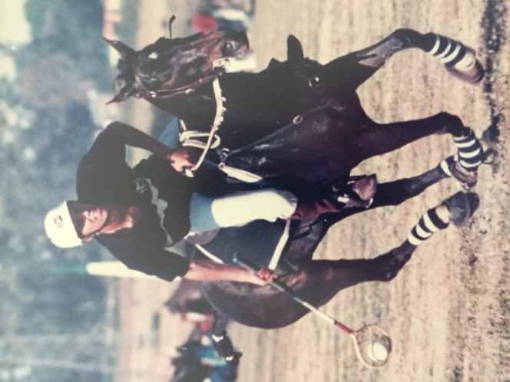

I was about 15 years old and had out grown my old gelding that I had inherited from my father. I needed a new horse to take my polox to the next level. My father, Rick, heard about a beautiful young horse that Bruce Hundley had recently been schooling which had been spotted at a local gymkhana.
It took me 20 seconds to realise I was sitting on a superstar. We broke the bank to buy her, R10 grand! Which was basically unheard of in those days, for a green but hectically beautiful, athletic, talented machine.

The very next weekend I had her at the first tournament of the year at Baynesfield playing in the A division. Bruce had failed to tell me that she had never played a chukka in her life. He had found her on a stud farm unraced, schooled her and sold her. Well she had a baptism of fire, but the truly great ones can handle anything, she literally flew and we never looked back.

I played her A division until she was 20, when she retired to stud still sound. Probably the fastest horse in polox, she had an incredibly soft mouth and was amazingly athletic. She played all 3 positions with not a quirk in sight.

Everything I achieved in polox was because of her. She took me from a 5 to a 9 handicap. Got me SA school colours, played a few SA U21 series against Zimbabwe where she won best pony and eventually helped me to achieve my senior national colours. In her last season she played for my girlfriend, Jean. They helped us win the PMB High goal tournament and they had a great SA champs.

Ranger was the new stallion in town, and she was duly sent off to produce us an able replacement for herself. Mayhem was born on the 3rd November 2003. He has had big shoes to fill but has so far done us and his mother proud.

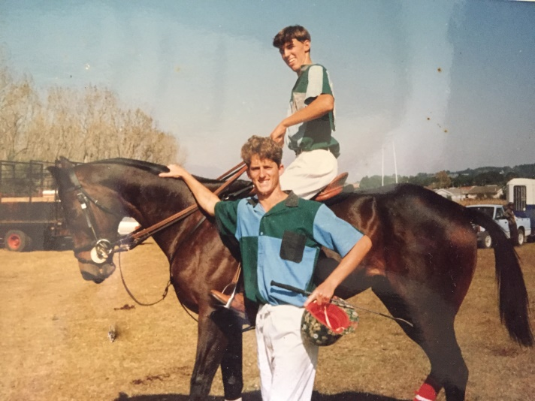
 BEST BIRTHDAY WISHES ON YOUR BIRTHDAY
January

1 - Murray Evans
3 - Hayley Horne
7 - Anthony Ward
- Dick Wheeler
- Murray Chapman
- Anke Du Toit
8 - Helene Steenkamp
9 - John Mansfield
- James Hackland
10 - Morrigan Halkett
11 - Emma Anderson
12 - Pierre Prinsloo
14 - Megan Hatch
15 - Brya Gillespie
17 - Natalie Maclarty
18 - Stefan Harris
- Andrew Heynes
19 - Thabea Schuch
- Melody Fitch
20 - Thilanie Groenewald
23 - Michelle Roods
24 - George Schabort
26 - Ethan Gourley
27 - Bradley Bekker
28 - Juliette Guse
31 - Hunter Russel





HORSES, etc

Looking for a horse box to lease? Contact Casey Bennett 0769040500

