
The ninth chukka
June 2016

CONTENTS: CONTACT US:
Umpire Whistle pasa@futurenet.co.za
Shongweni High goal
Birthday Wishes
Horses for Sale

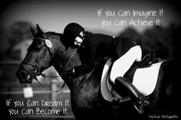

Good luck to all our juniors for their upcoming tours

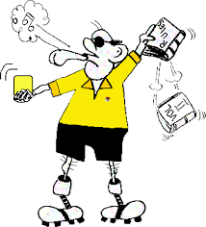 UMPIRE’S WHISTLE

Hi all.
Well May was certainly busy, so trust you all had a great month.

As chief umpire I attended High Goal at Shongweni, a 3 day event based on international rules, but certain rules prevailed to the tournament.

The field was well presented with all safety lines in place, spare goal posts (phew) and so on.
It was 4 games a day, over 3 days ladies and men alternating or preceding each other as the committee decided.

Top gun players from SA, Zambia and 2 from Australia- with wildcards to add to a team of 6, coaches decisions of how who and when.
A very exciting tense tournament, major sponsor Landrover, went over the top to provide the best sponsorship, support and expertise similar to WC 15- but more relaxed.
A pity that Royal show, Comrades marathon took many supporters away, however world class entertainment of Polocrosse for all and sundry.

Field was soft on horses, however became slippery on day 2 and 3,( no watering at all), and it was clear that some players had a BIG problem to adjust to the conditions underfoot. There was no mud at all, just some players didn’t adapt to the conditions. Horses tried their best to produce what the rider wanted, albeit to over 10 horses taking a spill- and one horse did not like the goal posts either, and decided to break it just to check I had done my job properly- luckily I did and knew that there were no hidden underlying obstacles inside the goal posts.!!!!!!!!

On day 3 a brief meeting with the committee after game 1 and 2- an ultimatum to players next to play, next horse falls( maybe I should have made a call sooner), we call rest of games off.
Know what????? Not 1 horse in the final game went down- amazing hey!!!!!

Umpires- thank you thank you- a tough job to all doing duty- we had a hard task ensuring that every game had a good top rated umpire, giving me a hard job to find available non players to do duty at this prestige event.
Steve Gilson, Paddy o Sullivan(player), Scott Hosking(player), Wessel Strauss, James Hackland, Mark Arnold, Wesley Flowers,- well done on good umpiring- we did a great job thank you.
To those players who got penalized, crops taken away, sent off- just a message to everyone, we are out there!!!!!!
To Mrs Von beneke and Ken-an excellent job at table duty- also thank you Michelle Witthoft for doing a great duty on the Sunday.
Remember, the time is dead, when the clock at the table says so- NOT THE SCOREBOARD CLOCK!!!!!!

To the ladies that made sure umpires and table were well looked after- thank you so much.

To the vets at the field every game- Manfred, Patrick and your team- thank you for your support and expertise!!!

Sponsors Landrover are up for the next 3 years with HIGH GOAL at Shongweni, so do not miss out next year for another spectacular TOP GUN Polocrosse event.

Cheers
Gav Flowers.



Land Rover teams take top spots at the inaugural Land Rover Durban HIGHGOAL polocrosse tournament

Superb weather, top quality polocrosse action and a beautiful setting ensured a highly successful inaugural Land Rover Durban HIGHGOAL tournament at the Durban Shongweni Club last weekend (27 to 29 May).

Both Land Rover men’s and ladies’ teams came out in first position after neck-and-neck games that saw all teams pushing themselves to the limit. Taking the prize in the ladies’ category this year was Land Rover Durban’s Team Evoque who walked away with R10 000 in cash following an impressive two-day display. The men’s final, held on the Sunday afternoon, was won by Land Rover after a highly competitive match. The Land Rover men’s team trotted away with a well-deserved R12 500 prize money and title as the first ever winners of the Land Rover Durban HIGHGOAL.

The event saw eight teams, four men’s - Branson, Zambeze Delta Anti-Poaching, Alzu and Durban Land Rover – and four ladies’ – Alzu, Team M&M, Rhino Truck Sales and Team Evoque – competing in a number of games daily.

The final four men’s and ladies’ games were held on Sunday. In the ladies’ division, Evoque beat team M&M 16-12 and Alzu beat Rhino in a closely contested 16-15 game. The final scores put Evoque first, Alzu in second place, M&M third and Rhino fourth.

For the men’s division, Branson took on Zambeze, finishing with a convincing 35-23 win while Land Rover finished the event off with a spectacular 35-24 win over Alzu. Final placings put Land Rover first, Alzu second, Branson third and Zambeze fourth.

Land Rover truly got their monies worth when their Evoque ladies’ team member, Jean Hackland - who took part in last year’s World Cup - and took home the prize for Most Valuable Player in the ladies’ division and also the Best Turned Out Pony.

The Land Rover men’s team also took home all the accolades as their captain, Andrew Heynes, took home the prize for Most Valuable Player in the men’s division and the Golden Pony award. Their Australian import, Lance Anderson, won the award for best No 2 player for the tournament.

“It was a fantastic event overall with world-class polocrosse players bringing their best to the field,” said event organiser and Shongweni Polocrosse club chairman, Brent Von Benecke. “Shongweni experienced the usual glorious weather for this time of year, and there was a great turnout with hundreds of visitors coming to witness the fast-paced action.”

Being a High Goal tournament, each team consisted of six players with a combined handicap of between 42 and 45 (out of a possible 60) where 0 is a beginner and 10 a world-class player. Showing its calibre, the tournament welcomed two 10-handicap players – Jannie Steenkamp and Graham MacLarty – to the field.

Andre Schrenk, dealer principal for Land Rover Durban, said they were thrilled with the success of the first Land Rover Durban HIGHGOAL, and looked forward to the 2017 instalment.

“There were eight teams, 48 players and about 100 horses who put on a really world-class performance,” said Shrenk. “There were a number of tight games that were all greatly supported.

“The weekend started with a gala black tie event and ended off with a prize giving. Land Rover Durban looks forward to sponsoring the 2017 edition.”

Schrenk said that supporting the equestrian market was a global mandate for the Land Rover brand.
“The Land Rover Durban HIGHGOAL is the ideal opportunity for us to achieve this and we are fully committed to sponsoring the event going forwards.”

Photographer: Shannon Gilson

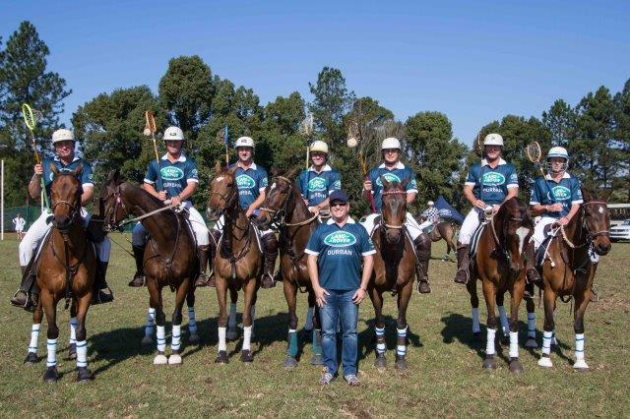
The Land Rover men’s team trotted away with a well-deserved R12 500 prize money and title as the first ever winners of the Land Rover Durban HIGHGOAL.

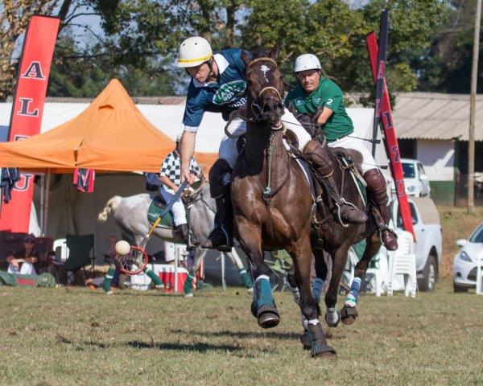
Scott Hosking (Team Landrover Durban).

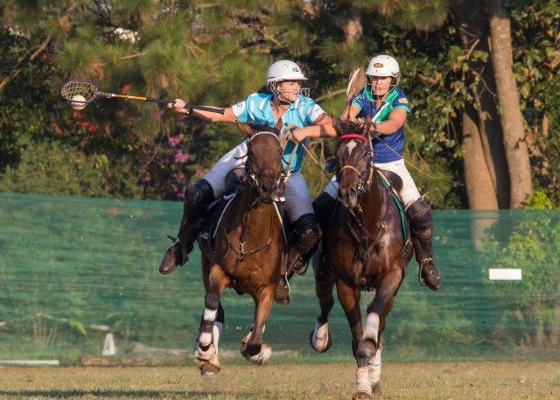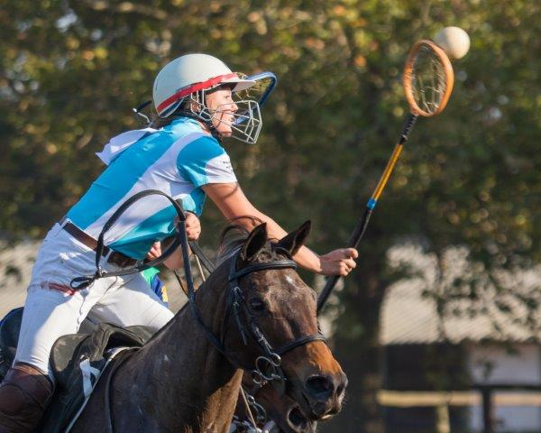
Amber Pretorius (Team Rhino Truck Sales) Tayla Mansfield (Team Rhino Truck Sales).
and Caroline Minnar (Team M&M).

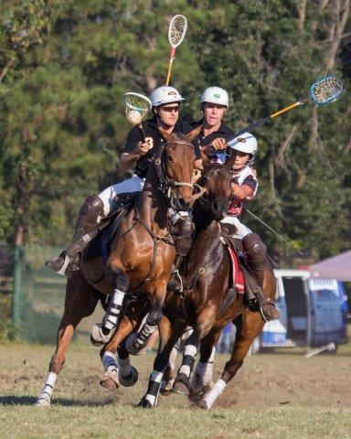
Damien Harris (Team Branson), Kenan Classen (Team Alzu) & Rudy Vorster (Team Branson).

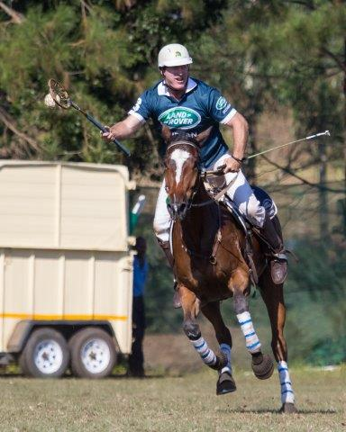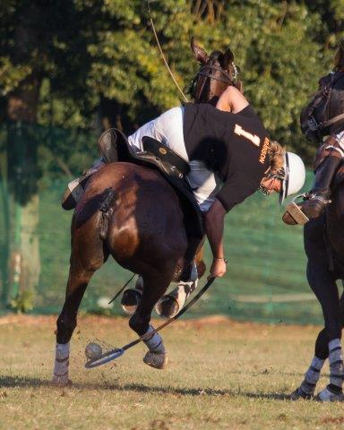
Gavin Cocker (Team Landrover Durban). Steff Harris (Team Branson).

Disseminated by:
Olivia Jones Communications

For more information please contact:
Olivia Jones Communications
Cell: 083 653 1720
Email: media@oliviajones.co.za

Thank you to Olivia Jones for all the media coverage received for the High Goal



June

1 - Lynton Bauer
2 - Emma Engman
- Stefan Van Der Merwe
4 - Anton Kruger
5 - Charles Van Wyk
6 - Ross Odell
7 - liam Classen
- Graeme Horne
- Micha Van Coller
9 - Ryan Pretorius
10 - Francois Koekemoer
- Klari Du Toit
11 - Julie Skinner
12 - Nicola Rae
- David Wisdom
14 - Jens Bunge
- Wian Starbuck
16 - Nadine Low Ah Kee
- Mike Elston
17 - lauren Try
- Anel Dafel
18 - Eduard Schuch
21 - Marlette Visagie
22 - Steven Godfrey
- Nikita Esson
23 - Pat Nkosi
24 - Debbie Dick
25 - Kegan Smith
27 - Natalie Schultz
- Peter Green
- Alastair Armitage
- Jean Hackland

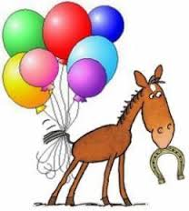
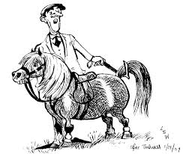

HORSES, etc

TB gelding for sale, has played polo and polocrosse. Loads easily. Contact Michelle Withoft 0844157448

For Sale
Super safe 1st or 2nd Pony for sale
Lovely all-rounder
Name: Merlin Height: 14.1hh
Age: 10 Breed: Mixed
Contact: Karen Boezio at k.boezio@siyayaec.co.za
Successfully competing in: Show Jumping (80cm); Working Riding and Equitation
Recently started playing Polocrosse, does some Dressage and would Event.

Boxes easily, stands for farrier and vaccinations, can live out, currently barefoot.
Uncomplicated, easy, confidence-giver for a young child wanting to try everything.
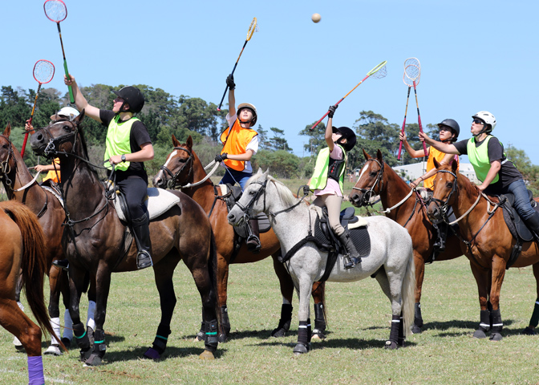
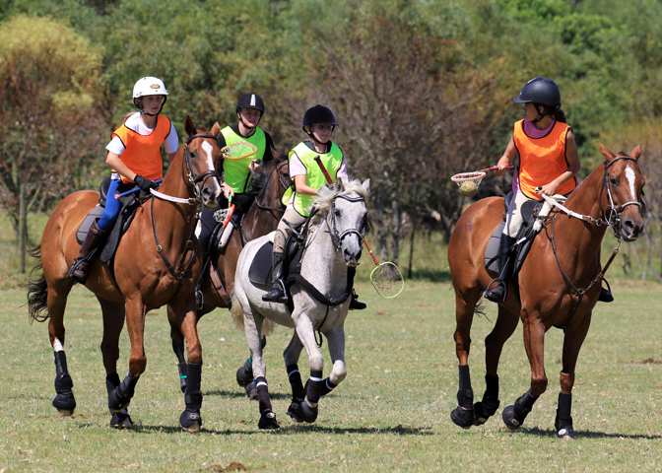
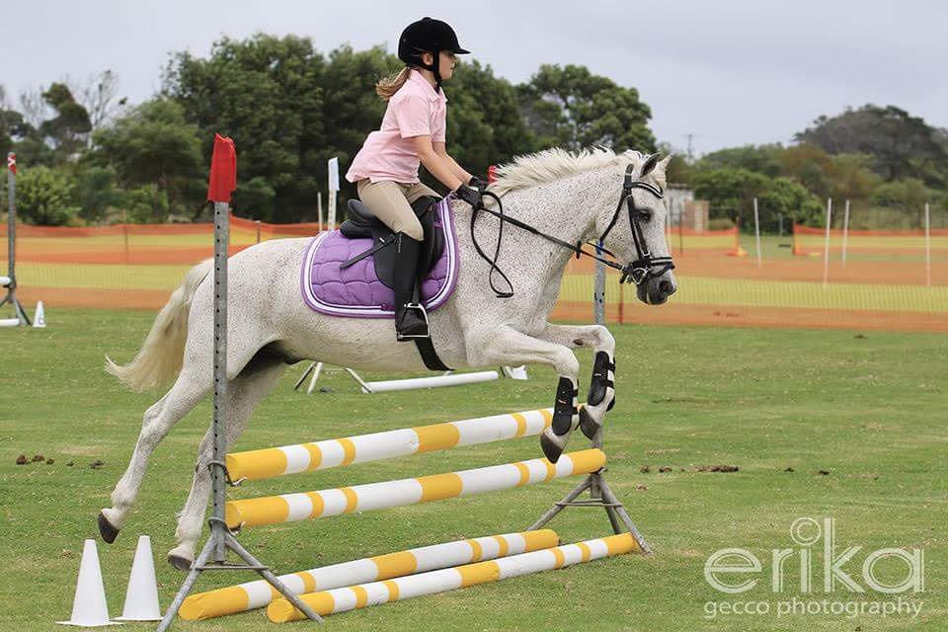
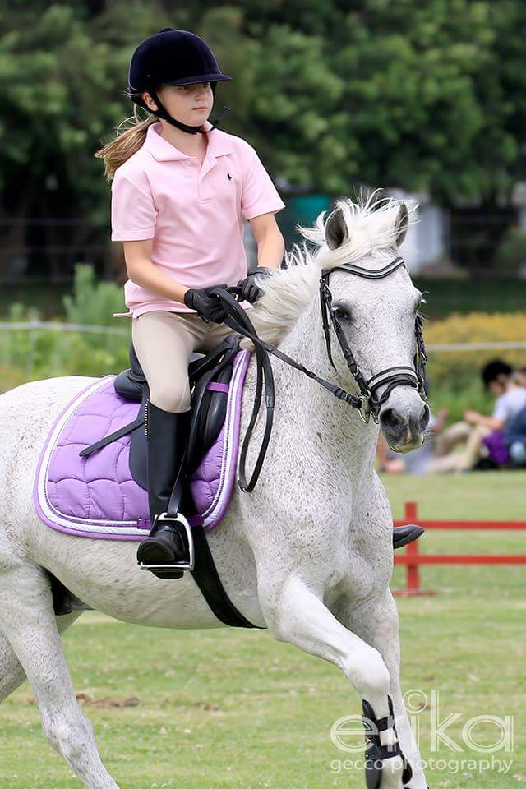
Current Owner has sadly outgrown him

HORSE BOX FOR SALE

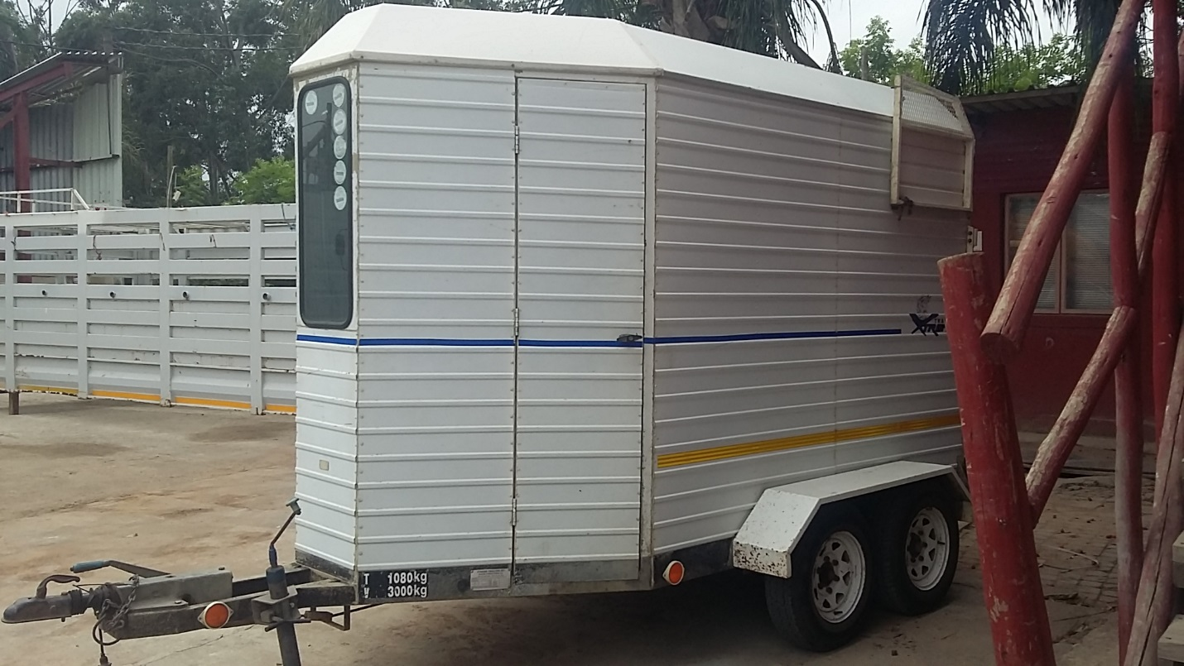

2004 EXTREME TRAILERS 2-BERTH HORSEBOX for Sale!
Fully licensed (May 2016-April 2017)
Spring-loaded ramp
Stainless Steel floor
Recently new tyres
Low overall mileage (we mostly transported our horses in a truck)
Very good condition
Tows beautifully
Fully lockable
Manufacturer makes the Horse Ambulances for both Phumelela & Gold Circle Racing.
Price: R45 000.00 Contact: Sam (082 7724893)

Contact Caron Visser 0835381203
