
The ninth chukka
March 2016

CONTENTS: CONTACT US:
Umpire Whistle pasa@futurenet.co.za
Fees 2016
Your Executive
PASA fixture list 2016
Birthday Wishes
Horses for Sale

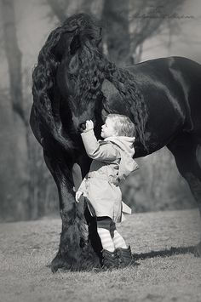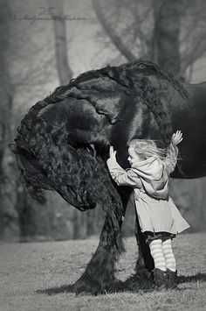
THE HORSE’S PRAYER
- AUTHOR UNKNOWN

To thee, My Master, I offer my prayer.
Feed me, water and care for me, and, when the day’s work is done, provide me with shelter, a clean, dry bed and a stall wide enough for me to lie down in, comfort and always be kind to me.
Talk to me. Your voice often means as much to me as the reins. Pet me sometimes, that I may serve you the more gladly and learn to love you. Do not jerk the reins, and do not whip me when going uphill.
Never strike, beat or kick me when I do not understand what you want, but give me a chance to understand you. Watch me, and if I fail to do your bidding, see if something is wrong with my harness or feet.
Do not check me so that I cannot have the free use of my head. If you insist that I wear blinders so that I cannot see behind me as it was intended I should, I pray you be careful that the blinders stand well out from my eyes.
Do not overload me, or hitch me where water will drip on me. Keep me well shod. Examine my teeth when I do not eat; I may have an ulcerated tooth, and that, you know, is very painful.
Do not tie my head in an unnatural position, or take away my best defense against flies and mosquitoes by cutting off my tail.
I cannot tell you when I am thirsty, so give me clean, cool water often. Save me, by all means in your power, from that fatal disease -- the glanders. I cannot tell you in words when I am sick, so watch me, that by signs you may know my condition.
Give me all possible shelter from the hot sun, and put a blanket on me, not when I am working but when I am standing in the cold. Never put a frosty bit in my mouth; first warm it by holding it a moment in your hands.
I try to carry you and your burdens without a murmur, and wait patiently for you long hours of the day and night. Without the power to choose my shoes or path, I sometimes fall on the hard pavements which I have often prayed might no be of wood but of such nature as to give me a safe and sure footing.
Remember that I must be ready at any moment to lose my life in your service.

And finally, O MY MASTER, when my useful strength is gone, do not turn me out to starve or freeze, or sell me to some cruel owner, to be slowly tortured and staved to death; but do thou, My Master take my life in the kindest way, and your God will reward you here and hereafter. You will not consider me irreverent if I ask this in the name of HIM who was born in a Stable.

 UMPIRE’S WHISTLE

Hi all.
Well a brief report back on our provincial umpires meeting in JHB- thank you those who attended, or sent a replacement- hopefully the message was sent back to you??????

So, we now have:-

A PASA horse welfare officer- Dr George Schabort’, well known to all, so glad to have you on board.
A horse welfare person for every tournament- club/ province must stipulate this on your tournament checklist.

Dr Schabort’ will be drawing up a document for the welfare person, to ensure items are addressed in the absence of a vet immediately on hand.

Now , an exciting issue addressing the umpire who misses an umpire duty, will be tried.
As normal, we will allocate the umpire person- BUT---------
Should the umpire NOT turn up for his duty, or as per the rules, allocate a replacement timeously, that umpire will be fined, but his club will pay- who in turn must get the monies back from the person at fault.
BUT should the club not pay!!!!! I as chief umpire will ensure that that club does not play its next tournament- ( it will be hard on other club members but!!!!!!!)
SO let’s hope this trial works –

The chain of command is club umpire- provincial umpire then me as a last resort.
We have a great panel of provincial umpires, so any problems please ask them, as I will be giving them my full support.

Hey hey hey-
Just to advise as well- on the score sheet which captains and umpires sign, will also have a portion to be filled in on the umpires- how did you rate them captains.
This will go to the provincial umpires for analysis, or to me where needed.

And we have finally been given the go ahead to print new rule books- both senior and for the up and coming- versions- chat with your provincial umpire regarding this.

In future I will be asking every provincial umpire to do their bit by doing the umpire whistle from each province- so get hold of your provincial umpire, make sure they write what you as players are needing.

Happy 2016 of Polocrosse, it’s a great sport so together , we MUST all have FUN.

Cheers
Gav Flowers.

PASA FEES FOR 2016 (INCLUSIVE OF SAEF FEES)
SNR/VET /U21/U19 R900
U18/U16 R700
U12/u14 R300
U8 FREE
TRANSFORMATION R250
SOCIAL/TECHNICAL R350
MEMBERS TO AFFILIATE THROUGH THEIR CLUBS TO PROVINCE TO PASA, NO DIRECT AFFILIATON TO PASA WILL BE PERMITTED!

YOUR EXECUTIVE…….
President Hannes Van Aswegen Cell: 0833139025
Email: hva@mtnloaded.co.za
Vice President Francois Du Toit Cell: 0824624760
Email: francoisdt40@gmail.com
Secretary Ashleigh Shaw : Fax: 0865715903
Cell: 0748916657
Email: pasa@futurenet.co.za

Treasurer Trish Swanepoel Cell: 0825652051
Email: pasa.pro@futurenet.co.za

Chief Umpire Gavin Flowers Cell: 0794591727
Email: flowers@lantic.net
Chief Handicapper James Hackland Cell: 0836370792
Email: jhackers@pmbnet.co.za
Junior Polocrosse Sam Heynes Cell: 0829386710
President Email: heynes@vodamail.co.za

Director of Andrew Heynes Cell: 0829030698
Coaching Email: Andrew.Heynes@omnia.co.za

Convener of Peter Choice Cell: 0833004488
Selectors: Email: peter@choicecarriers.co.za

International Karen Odell Cell: 0832790982
Relations Email: karen@branson.co.za

Development Brent Von Benecke Cell: 0824184703
Officer Email: brentvb@w2k.co.za

Chairman Francois Du Toit Cell: 0824624760
Of Disciplinary Email: francoisdt40@gmail.com
Committee

Veterans Ron Sparrow Cell: 0736679923
Co coordinator Email: drs.tdou@gmail.com

Players Representative: Emma Hall Cell: 0836403649
Email: emmasuehall@yahoo.com
Horse Welfare Officer: George Schabort Cell: 0768775651
Email: ga.schabort@gmail.com

 | TOURNAMENT FIXTURES 2016
DATE | TOURNAMENT | VENUE
JANUARY
FEBRUARY
27/28 | DSC green horse | Shongweni |  | CANCELLED
MARCH
5/6 | Walkerville Chukka Champs | Walkerville
 | Tenikwa Tournament | George |  | **************************************************************
 |  |  |  | ALL TOURS, TOUR DATES AND TOUR VENUES
12/13 | Mooi River Start of Season | Mooi River |  | ARE SUBJECT TO CHANGE
 | Bethal tournament | Bethal |  | ***************************************************************
19/20
25/26/27 | Tegwaans Easter tournament | RICHMOND
APRIL
30 March - 3rd | JUNIOR CLASSIC | Mooi River
9/10 | PEPC Autumn | PE
16/17 | MP champs | Bethal
23/24 | Umvoti | new venue Greytown
30/1/2 | WINDPOMPFEES | Mokgopong/ Nylstroom
 | East London Agric | East London
MAY
7/8 | BISHOPSTOWE | BISHOPSTOWE
 | Vryburg | Delareyville
14/15
21/22 | WP Champs | Saldahna
 | GP Champs | Arnot
 | KARGS POST | Kargs Post
28/29
JUNE
4/5 | Natal Champs | Richmond
11/12
18/19 | Veterans tour | Bulawayo, Zimbabwe
25/26 | Zambia Open | Livingstone
JULY
1-3 | IPT | PE
8/9/10 | Junior U14 outgoing tour | Zambia
12-17 | Junior festival u16/u19/U21 vs Aus | PE
23/24
30/31 | EP Champs | East London
AUGUST
6/7 | Walkerville Turnabout | Walkerville
 | Paddock tournament | Paddock
13/14 | Shongweni High Goal Men & Ladies | Shongweni
20/21
26/27/28 | SA Champs | BETHAL
SEPTEMBER
3/4
10/11 | NORTH WEST CLASSIC | Huhudi
17/18 | PEPC Spring | PE
24/25 | Snoek Tournament | Saldahna
OCTOBER
1/2 | CAPE CLASSIC | Saldahna

PLEASE ENSURE EVERY PLAYER IS AFFILIATED BEFORE ENTERING INTO A TOURNAMENT.



March

2 - Chanelle Bothma
- Keighley Van Wyk
- Kate Dolby
3 - Ross Beukes
5 - Gert Van der Merwe
- Kelly Fletcher
6 - Brian Cooper
8 - Caley Higgs
- Jarryd Jacklin
9 - Callum Shaw
10 - Trent Cocker
12 - Allan Oates
13 - Francois Du Toit
16 - Tim Halle’
17 - Heather Campbell
18 - Dries De Villiers
- Attie Van Wyk
- Nico Van Wyk
19 - Thomas Lynn
- Graham Maclarty
20 - Sherri Von Onselen
22 - Marique Wilkinson
23 - Mandy Rapson
25 - Eric Kuhn
26 - Nikki Crook
27 - Camryn Minnarr
28 - Gordon Shaw
29 - Jade Janse Van Rensburg

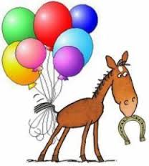
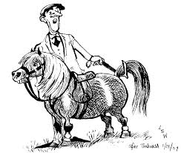

HORSES, etc

TB gelding for sale, has played polo and polocrosse. Loads easily. Contact Michelle Withoft 0844157448

Kilmore Saddle for sale: Langdon Taylor 0834110794

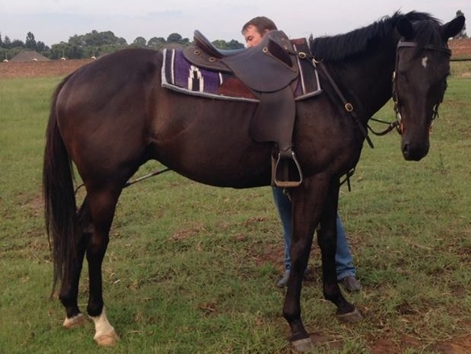

2 Brand new Gordon Shaw saddles for sale R10 000 each as well as new bridles
Contact Jonathan Metcalf 0836791069
.

