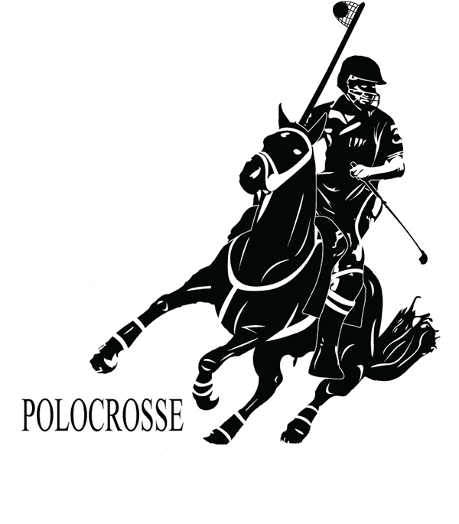
The ninth chukka
March 2017

CONTENTS: CONTACT US:
Umpire Whistle pasa@futurenet.co.za
In the Line of Duty
Portfolio Update
Night Races
Birthday Wishes
Horses for Sale

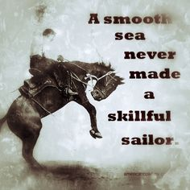

UMPIRE’S WHISTLE

Hi all,

UMPIRE CLINIC 11/12 FEB.

I believe a great clinic, from reports received, but unfortunately only 3 provincial umpires could attend NW, Limpopo, and Gauteng.
However we had 34 other attendees, which was excellent as all were players from NW, Gauteng and Limpopo.

We started with playing rules( all 32), which took quite long, as we had lots of discussions and I believe , going forward , was good to discuss and interpret rules where needed.
A New rule test was done and completed by all, allowing many to see inside the rule as to what it actually is.
Videos, which I had prepared with times of incidents, were then viewed and again seeing an incident, we did rewinds many times to see what actually happened, so that we all were on same page.

On the Sunday, we did non- playing rules (all 23), again ensuring everyone’s interpretation, was the same.

Every person attending- got a whistle, a certificate, plus a copy of the new rule book.

RULE BOOKS

The new rule book is out, and Ashleigh our PASA secretary has stock at R50 each, money going into the umpire kitty for umpiring.
Thanks must go to Hilton and Kentucky Polocrosse clubs, who made these books possible.

OTHER MATTERS.

- Dedicated umpires who only umpire at a tournament- we only have 1 so far- we need to work hard on this to get names please.
- IPC umpire meeting and IPC umpire clinic was cancelled by the IPC- no reasons given.
- Senior tour to Australia, Paddy has attended squad camps and is doing well with the team. Both Paddy and I, are working hard to ensure the team has all our support for this tour.
- TMO and drone testing- unfortunately my efforts with the drone are not going to work- not enough seen from up there, plus drone pilots need licenses to do sport and so on.- but the TMO is still the way to go with video footage- but we need elevation to see more.

STALLION ALLOWED TO PLAY.

There is only 1 stallion, who has met and been under the executive directives, playing at Shongweni, but under strict controls- so far in 2016, no problems, allowed to play again in 2017- again under strict controls.

KZN International umpire school/clinic June 2017.

Directly to IPC cancelling the IPC umpire meeting and school in 2017, I looked at doing something here in SA, as we have the perfect opportunity to do a umpire clinic of International standard, especially with UK and USA incoming senior tours in June. Zimbabwe and Zambian chief umpires both have agreed to attend our clinic as well.
Therefore- the executive yesterday gave permission to go ahead with the plan, of having 5 countries present, to do a SA international type of umpire clinic.
This will take place over 2 weekends of Natal Champs and the Quadrangular in Mooi River- we will ask Australia, New Zealand and Ireland as well, but do not see them attending-
During the week between the 2 weekends, classroom style sessions will be held. High level umpiring and analysis will be on the 2 playing weekends.
Thanks to all those who prompted me to look ‘out of the box’ to ensure SA becomes a leader in umpiring and not just part of the flock.

UMPIRES NEEDED.

We need to prepare and ask our provinces, for good umpires, to do duty at the following.

- JUNIOR CLASSIC AND EASTER TOURNAMENT ( France are sending juniors to these weekends)
- NATAL CHAMPS AND QUADRANGULAR (yes we will have 5 countries umpires, but there are many teams where good umpires are required)
- INCOMING JUNIORS FROM ZIM/ZAM BARBARIAN TEAMS will be here to play at one of our local tournaments during 2017.
- U14 SA vs. ZAM ( OFFICIAL TEST- at Paddock in August ( nomination process will be sent out soon)
- Unfortunately the master’s tour to Zimbabwe has been cancelled.

DIRECTIVES FOR THE UMPIRE PANEL

Following the successful umpire clinic at Walkerville, another 2 clinics have been planned – dates and venue to be confirmed- in the Cape and KZN.
Also from the umpire clinic, umpires stated that no umpire horse will be umpired on, if the umpire cannot do his job correctly on that horse- the horse will be returned and either Captains horse will be used or another horse is IMMEDIATELY available-
EXECUTIVE DIRECTIVE TO UMPIRES- We WILL up our game and ensure crops and spurs are correct and are being used correctly- it is our DUTY to enforce these rules of horse aids by players. Horse welfare at club level, provincial level and international level, have been instructed to ensure these aids, plus horse welfare issues are TOP PRIORITY at all levels of play in SA.

Have a great 2017 season in Polocrosse- lots of great things happening.

Cheers
Gav Flowers
PASA chief umpire
0611243571

IN THE LINE OF DUTY ……
MEMORY by Sarah Van Wyk

My Dad Andrew Erskine, had a mare Nightmare, that had a bad ride off and chipped her hip. The only way to keep her sound and playing, was to trot her everyday up and down hills for half an hour every day. This was diagnosed after spending time with Winks Green (Physiotherapist). The only problem was you could not skip a day of work, after lots of thought my Dad decided to put Nightmare to a Stallion.

This was his first breeding experience; he spoke to Pete Hilliar and sent Nightmare to his Stallion, Superbeat. When Nightmare came back from Superbeat she was pregnant, but had been in an encounter with a snake and had lost her sight in the one eye. Nightmare was a happy broad mare, that ran in between our playing horses and as horses can be she was chased and being blind in the one eye ran into a tree and lost the sight in her good eye. Being totally blind she was moved to a paddock close to the house with old tyres on everything that could injure her. Closer to her due date a night guard was put on duty in the evening to call us if anything went wrong.

On the eve of 14th December 1989, the guard came to call us at about 5:30, we all went out to see what was wrong. We were so lucky to watch the whole birth of Memory (Named in loving Memory of Nightmare). Nightmare was a wonderful mother and soon Memory was her eyes and she followed Memory everywhere. Memory lived the normal life of a foal, then yearling and was at last, broken in by my brother Stuart Erskine. When we left Fawn Lease to move to Bosch Hoek Nottingham Road, Memory would not load onto the truck with the other horses, so was walked to my Uncle’s (Stephen Erskine) about 40km to stay there until we could load her. At last she loaded and was trucked to Bosch Hoek lying down on the truck every time the truck went under a bridge. My Dad played her a lot of young polo chukkas and introduced her into the game. He also spent many hours schooling her, thanks Dad she was my best horse. When I returned from Australia in 1996 I started playing her. I will never say it was a breeze, we had a love hate relationship and she tried to get you off in every way possible. When Charles and I were selected to play in the Quadrangle in PMB in 1997, we had to put 3 horses into the pool each. Memory and I were still in our love hate relationship and Charles played her beautifully I tried very hard to swop him for a mare of his “She's a Wizz” but his Mum Dawn van Wyk, was having nothing of it. She went into the pool at the Quadrangle and Zimbabwe drew her, she only lasted one practice and went lame. So she was loaded and taken home, she was never lame before or after that practice. She then became my game and my rock on the field, without her I would never have been the player I was. She had the fastest take off and was as soft as butter in the mouth. I played her every tournament and rode her most days at home, until 2002 when I broke my leg and decided to have a second child and thought it would be good for her to have her first foal. She fell pregnant but I didn't and I needed her the following season 2004 so she was brought back into work early with her foal at foot (Which was Amjongosi now played by our nephew Attie van Wyk) she played for two more seasons after that. She was then retired to be a brood mare she gave us 4 beautiful foals that are all playing and keeping the legend alive.

All the mares got out and ran around the farm in 2008, when Charles got them back into the paddock she turned and walked up to him and looked at him and lay down, she was watched in and out of this world. 20 years of tears, joy, love, hate and many happy hours on the Polocrosse field.

Thank you Memory love you forever, till we meet again.
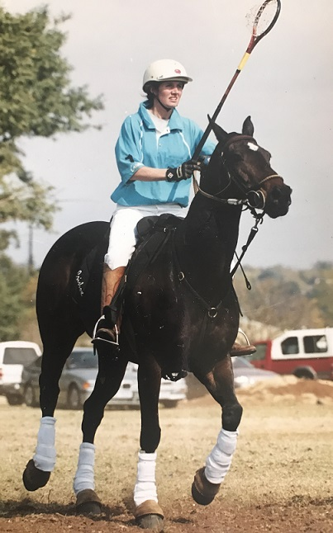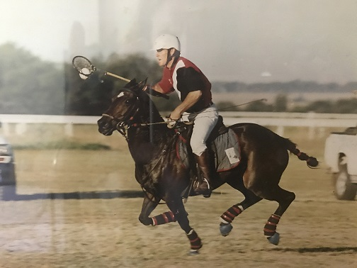
Portfolio reports
Every month we hope to bring you a report from members of the Executive on their portfolios. We are hoping to achieve complete transparency with our members and keep everyone up to date with the ‘goings on’ in PASA.
Director of Coaching – Andrew Heynes
We have a great season of polocrosse ahead of us. The Senior Men and Ladies teams touring to Australia in April are well into their preparations. Bruce Maclarty is Coaching the Men and Gavin Cocker the Ladies. The following Tours are coming up later in the season. I’ve given a brief description of each tour so everyone is in the loop.
U14 vs Zambia – 4/5/6 August
Mixed team of 7 players
Nomination forms went out for the U14 Coach. These forms were meant to be in by 10th February. No nominations were put forward so I will be appointing the Coach and Assistant Coach. These appointments will be ratified by the PASA Executive. These 2 positions will be announced on 3rd March 2017.
The selection tournaments for this side shall be Mpumalanga Champs, Junior Classic and Tegwaan’s Easter Tournament.
The announcement of the team shall be on Sunday 9th April 2017 after the Easter Tournament Prize-Giving.
U16 an U19 vs Zim/Zam Barbarians – 15/16 July
2 U19 Boy sections / 1 U19 Girl section / 1 U16 mixed team
This is an Unofficial Tour therefore there is no nomination process required for Coaches. I will be announcing these Coaches in due course. Please let me know ASAP if you are interested in Coaching.
The selection tournaments for these sides shall be Mpumalanga Champs, Junior Classic and Tegwaan’s Easter Tournament.
The announcement of the team shall be on Sunday 9th April 2017 after the Easter Tournament Prize-Giving.
SENIOR QUADRANGULAR vs USA and UK – 9/10/11 June
2 Men and 2 Ladies teams (7 players in a team)
This is an Unofficial Tour therefore there is no nomination process required for Coaches. I will be announcing these Coaches in due course. Please let me know ASAP if you are interested in Coaching.
There are no specific selection tournaments for these sides. The announcement of the team shall be on Sunday 9th April 2017 after the Easter Tournament Prize-Giving.
Junior President – Sam Heynes
Herewith a few lines and updates on the Junior Sector of Polocrosse;

- Australia sent an invite to our U16 juniors to join in their Junior Classic this year, and we have a group of girls and boys going along from SA, so we’re very excited for that.
- Junior Classic is set for the first weekend in April at Mooi River, entries close on the 10th March and space is limited as we have some Zambian and French kids joining in.
- We have some tours happening for this year, U14 due to play Zambia again at Paddock in August, U16’s and U19’s will also play a Zambia/Zimbabwe Barbarians team. So we are very excited for that.

INTERNATIONAL LIAISON – KAREN ODELL

Senior tour to Australia in April:
Preparations are in full force for this tour to Australia including ironing out of the details of the playing conditions with Australia.
We wish the team every success and trust they will do SA proud.
Please all support the fundraising initiatives.

Junior Tour to Australia :
There are a lucky 4 x U16 boys and 4 x U16 girls going to Australia in April to attend the Junior Classic in Albury with Caroline Minnaar as their coach.
Sam Gilson, Ruth O’Sullivan, Keara Mattheus, Cameron Minnaar, Jens Bunge, Josh Le Roux, Ethan Gourly.
They are sure to have fun and learn a lot.
A special thanks to Shannon Gilson for her assistance in the organising of this touring group.

Senior tour to Zimbabwe:
Unfortunately, this tour has been cancelled.

Junior Classic:
We have some French players and possibly some Zambian players coming to join in our Junior Classic and Easter tournament.

Senior Quadrangular:
The USA and UK are both sending teams to play in a quadrangular in July. Two ladies teams and two men’s will be selected to play.

Junior Festival in July:
Zimbabwe and Zambia have confirmed that they will send both U16 and U19 barbarians team to play in SA in July.
The details are in the process of being finalised.
More details to follow when they are confirmed.

U14 vs Zambia in Paddock:
Zambia are sending a team to Paddock to play SA in August.

Gauteng Polocrosse Communication - Ross Beukes GPA President

Our Gauteng clubs are rearing to go and looking forward to an epic IPT.
The year started off with many new executive members elected into the Gauteng Polocrosse Association (GPA). Although quite daunting at times, I believe we have made great strides already and are working hard to continuously improve GPA.
We’ve used mobile media to initiative active correspondence with and between members, fostering a collaborative atmosphere. 3 of the 4 clubs in GP have already held open practices, inviting players from the province to join them and learn from the skills their members have to offer. We believe that practices like these go a long way in building skills, developing team spirit and bringing on horses. I’d like to thank the clubs that have opened their doors, and the people who have offered coaching.
IPT is our aim this year - we hope to be well represented at IPT 2017 and have already started our IPT coaching and selection planning for the year. We hope that the exposure and coaching that players will receive this year will put them in good stead for the upcoming tours in both 2017 and beyond. Watch out guys – GPA is coming.
GP showed great support of the Umpire Clinic held at Walkerville. It was a brilliant weekend and a lot was learnt by all. Thanks to Gavin Flowers for conducting the session, to Walkerville Polocrosse club for hosting the clinic, Kentucky Polocorsse club for their generous book sponsorship and to Michael Kayne who sponsored the printing of the additions and rule adjustments to be added into the books. It is wonderful to see GPA members doing their bit for polocrosse and I look forward to seeing the skills learnt at the clinic put into practice this season.
I would like to take this opportunity to thank each GPA member for their support so far. I look forward to a fantastic 2017 season.

RAFFLE TICKETS ARE STILL AVAILABLE FROM THE PASA SECRETARY. THE DRAW FOR THE CAR IS ON THE 11TH OF MARCH. PLEASE SUPPORT US!

NIGHT RACES AT GREYVILLE RACE COURSE ON THE 3RD OF MARCH FROM 17H30. SHOULD YOU WISH TO PURCHASE TICKETS TO ATTEND THIS FUNDRAISING EVENT, PLEASE CONTACT SAM HEWITSON ON 0827724893 OR JUSTSAM@VODAMAIL.CO.ZA. THIS PROMISES TO BE A VERY EXCITING EVENING.
This is more than just a fund raiser for the Aussie Tour. We want to establish a brand for polocrosse. Like everyone thinks “Polo” is “all that”! I want this to be an annual “must do” on our polocrosse and social calendar.
We need to offer our sponsors more than what we have in the past. A sense of pride and belonging, being a part of something special.

We SOLD 5 races to the following 5 sponsors:
Choice Carriers – Peter & Karen Choice
TraderPlus – Dudley Cherry (non-polocrosse)
RCA Marketing – Murray Chapman
National Heavy Haulage – Kevin Soal
Farmers Agricare – Paddy O’Sullivan

Please support them before anyone else if you need the type of services they offer.

In thanks for their KIT SPONSORSHIP, we GAVE naming rights to the following 2 Main Sponsors:
CLV Group – COALVEST (Nlanhla Madlane) Men’s sponsor (thanks to Helene) non-polocrosse
TWK Agri Insurance (Connie Vermaak) Ladies Sponsor (thanks to Elri) non-polocrosse

We have given them: tickets to dinner, have advertising boards made up for display on the track rail, a race named after them (and referred to in all race cards and newspapers). They get to go to the start of the race, they get to sip champagne in the Parade Ring and maybe interviewed on TV. These Sponsors are travelling from Limpopo & Mpumalanga to be with us on the night.
It is our job to put them on social media and entertain them on Friday night.
We have sold an additional 150 Dinner Tickets to the NIGHT AT THE RACES. We have asked polocrosse & non-polocrosse friends to support us.

Please support us by believing in, buying-into & supporting our ideals & efforts.
The entire polocrosse community (and family and friends in Australia, America, Europe, South and the rest of Africa) can tune in on Friday night and feel like they are part of this prestigious event. Try and spot someone you know.

Thank you
Sam

 BEST BIRTHDAY WISHES ON YOUR BIRTHDAY

March

1 - Morgan Du Toit
- Robyn Marais
2 - Keighley Van Wyk
- Kate Dolbey
3 - Ross Beukes
5 - Gert Van Der Merwe
- Kelly Fletcher
6 - Brian Cooper
8 - Caley Higgs
- Jarryd Jacklin
9 - Jeanine Kotze
- Callum Shaw
10 - Trent Cocker
11 - Marischke Groenewald
12 - Allan Oates
13 - Francois Du Toit
15 - Lindsey Nortje
- Cassidy Gillespie
16 - Bryden Thomas
17 - Heather Campbell
18 - Emmy-Lou Miles
- Attie Van Wyk
- Nico Van Wyk
- Dries De Villiers
19 - Jill Moore
- Tanya Russel
- Dewet De Villiers
- Thomas Lynn
- Graham Maclarty
- Warren Valentine
21 - Keith Toucheer
22 - Riaan Delport
- Marique Wilkinson
- Marco Bianchi
- Mandy Rapson
24 - Marc Ward
25 - Eric Kuhn
26 - Nikki Crook
27 - Sarah Cawood
- Cameron Minnaar
28 - Gordon Shaw



HORSES, etc

