
The ninth chukka
November 2015

CONTENTS: CONTACT US:
Umpire Whistle pasa@futurenet.co.za
EP champs report
Birthday Wishes
Horses for Sale

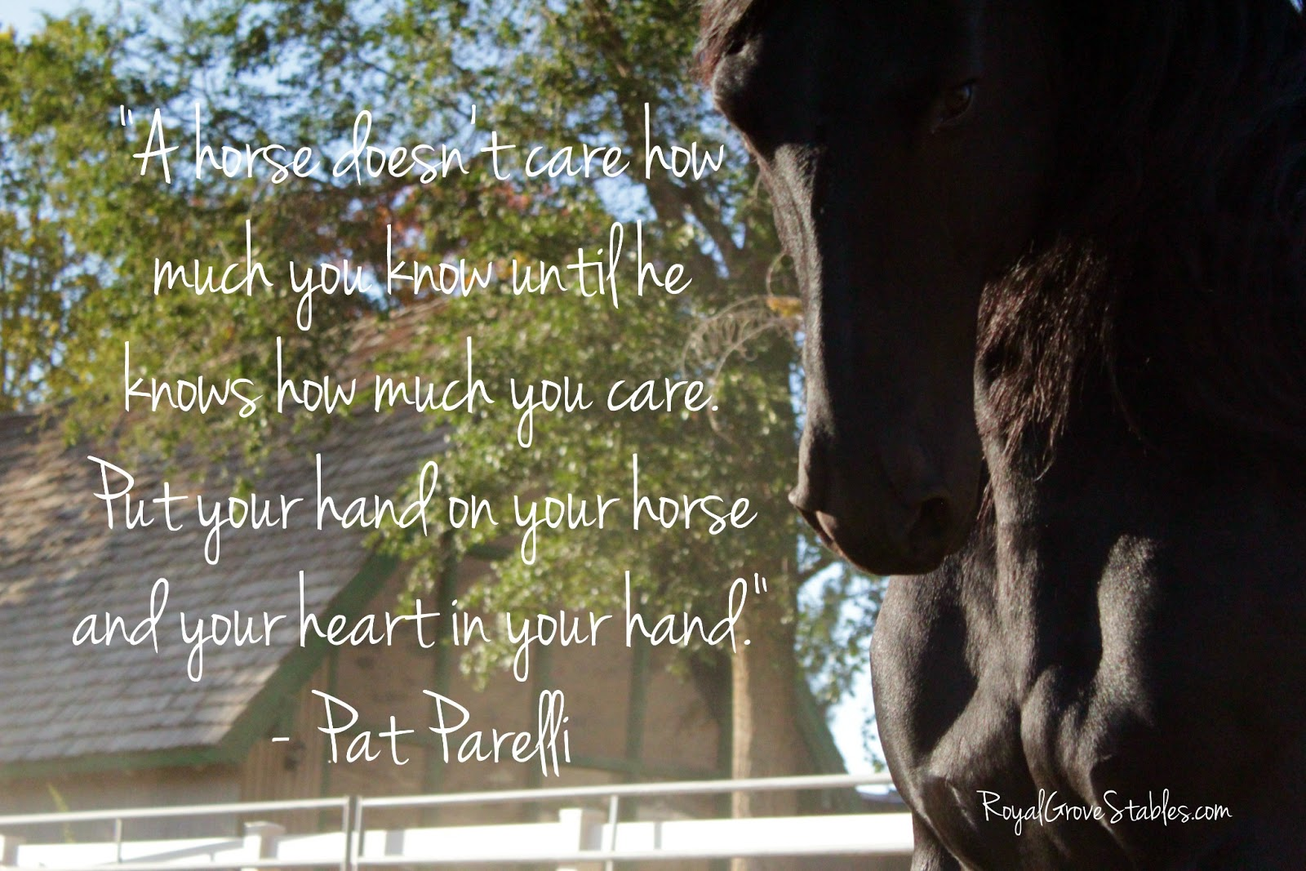

DON’T FORGET TO CHECK OUT THE PASA WEBSITE AND KEEP UP TO DATE WITH WHAT’S HAPPENING.
WWW.POLOCROSSE.CO.ZA

 UMPIRE’S WHISTLE

So guys another season has come to an end, I would like to thank all the provincial umpires for all the hard work that they have done behind the scenes during the year and for ensuring that the rules were adhered to.

We need to take umpiring very seriously as without umpires we cannot play this amazing sport, at SA Champs we held an umpires meeting and only four umpires attended the meeting, considering the amount of games that we had over the two days this is a bit shocking, please could all players who are umpiring make sure they attend these meetings as it is vital for the smooth running of games. I urge all players to please read through the rule book with their club umpires and make sure you understand each and every rule that is there.
Please assist the tournament committee, if you cannot do your umpire duty for some or other valid reason, please take the responsibility to find a replacement umpire, of a similar standard to do your umpire duty, and inform the tournament committee. If you expect an umpire for your game, then the players of the game you are supposed to be umpiring, deserve the same respect.

To the players remember the Umpires blow the whistle for what they see, everyone makes mistakes but this does not give us the right to argue with their call, by all means the captain of each team may chat to the umpires between chukkas if they are unhappy.

Once again if you have any questions please feel free to contact me

Andrew

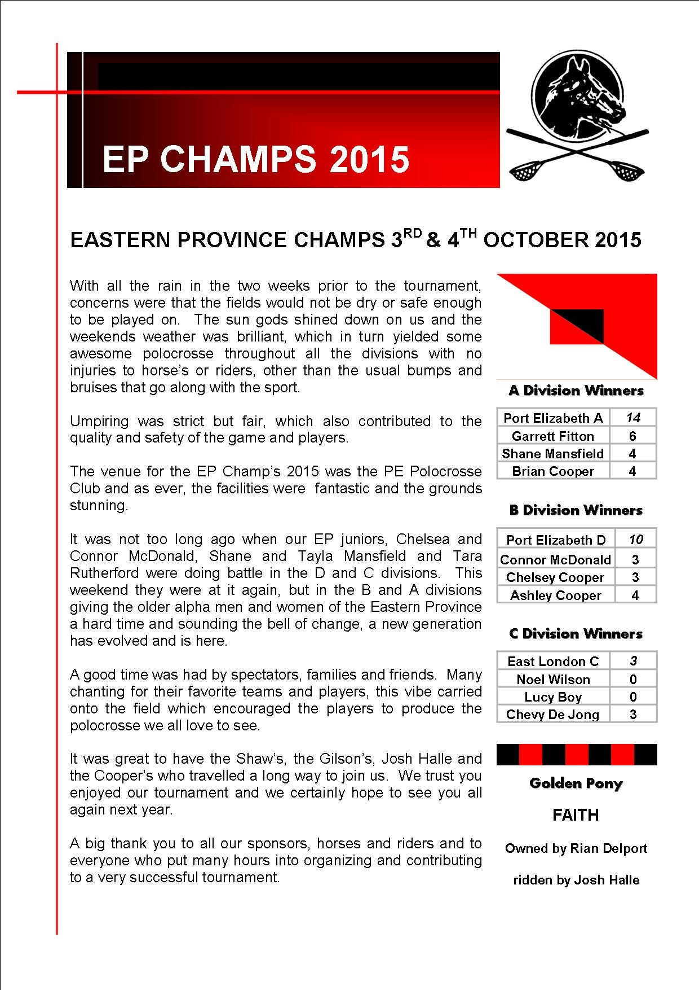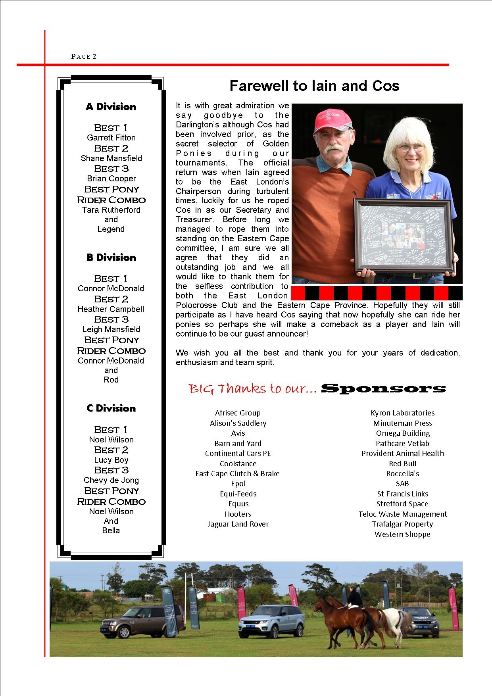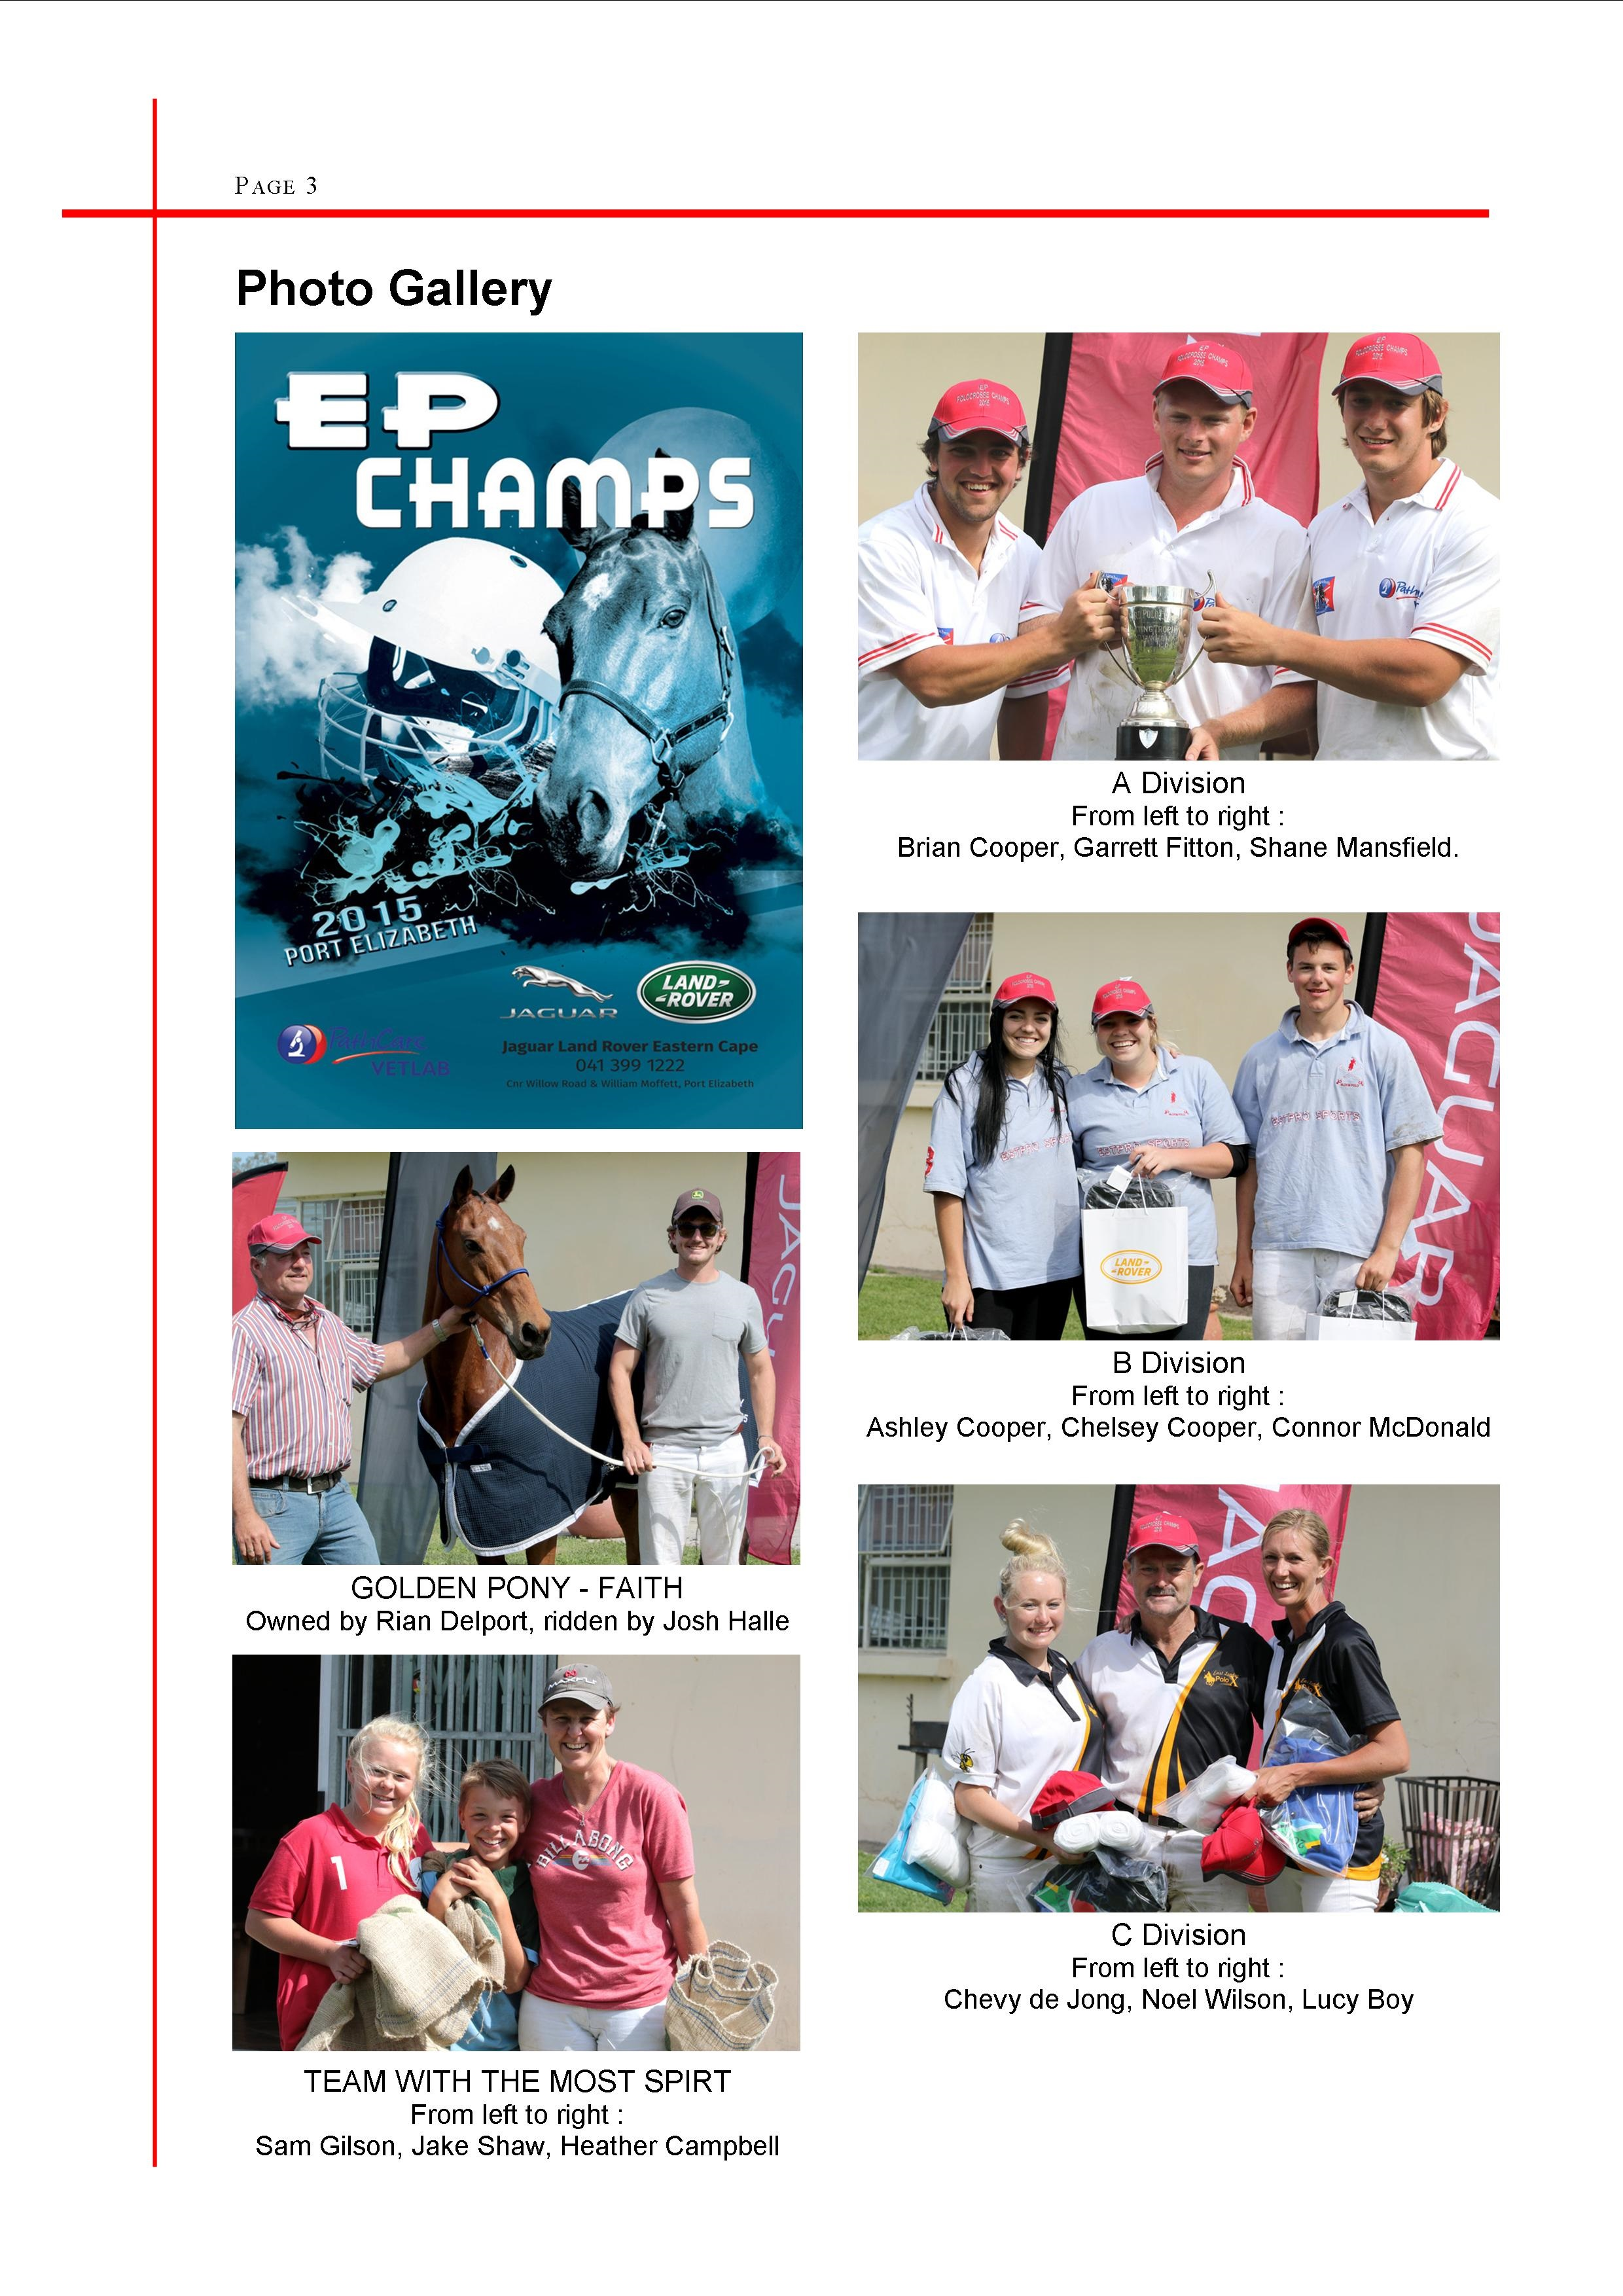
- 

NOVEMBER

2 - Graham Powell
- Sheryl James
3 - Emma Hall
- Dawnay Jacobs
5 - Jenny Firth
6 - Tarryn Higgs
7 - Tony Higgs
- Samantha Gilson
9 - Mark Rubin
12 - Craig Green
13 - Ross Dolby
15 - Amy Cocker
17 -
18 - Michelle Hucker
- Chris Newton
19 - Ron Sparrow
20 - Candice Odell
22 - Shaun Wheeler
23 - Bruce Mclarty
25 -
26 - Iain Darlington
- Garth Muhl
- Mark Arnold
27 - Pierre Scheepers
- Ty Von Onselen
30 - Lauren Heynes





HORSES, etc

HOLLEY : 12 year old Bay mare, 15.3hh. This big strong mare has a massive heart and is great as a 1, 2 or 3. She has a lot of experience, sad sale due to owner giving up riding. Would suite experienced rider. R15 000.00
Contact: Priscilla Dent at tambotitrading@gmail.com

Marinda Miles is looking to buy a Kilmore Stock Saddle, please contact her on 0832634387, if you can be of assistance.

Allisons Saddlery is going online. The new website will be up and running is a couple of weeks, but if you are looking for any equestrian equipment you can email sales@saddlery.co.za for a quote



