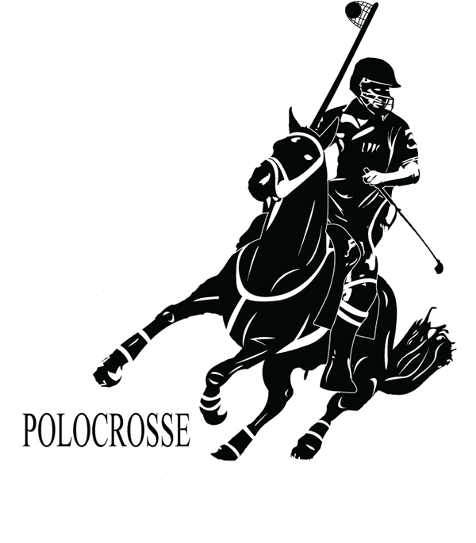
The ninth chukka
November 2017

CONTENTS: CONTACT US:
Umpire Whistle pasa@futurenet.co.za
Cape Classic 2018
Equine Respiration
Umpire report PE Spring
Birthday Wishes
Horses for Sale

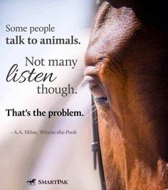

UMPIRE’S WHISTLE

AGM’s are happening, and so far we welcome the following provincial umpires onto the umpire panel.

KZN – Debbie Dick
NW- Maverick Gillespie
Both above were voted in for their 2nd term of office- well done.
Rest of provincial umpires will be sent out when we receive them.

An interesting couple of months past and I would like to comment of the following;

Rule 35(i) remember this rule for riding through goal posts- very dangerous – goal on board against player-plus opposition also get free throw from T area.

STATS 2017 in PASA – 9 incidents during 17 where horse and rider went through the goals- absolute ridiculous acts of dangerous riding!!!!!!!!

Concerns and misconceptions.

Rule3- one horse per player per tournament- but In SA we have an allowance for SA only, multiple horses in a tournament- tournament committee decision.
THIS RULE IS- 1 HORSE PER GAME-
For some reason there are players who have a misconception here- if a tournament committee sends out an invite and says on invite multiple horse tournament
This means for the tournament playing 3 games over the weekend, you are allowed to play 3 horses, but only 1 horse for every game-
You cannot decide to change between chukkas ( unless your horse is injured and we have rules for this.)
Your horse has to be fit enough to play 3 x 6 minute chukkas. And no you cannot play another person’s horse in the same game!!!!!!

Rule 6- size of ground and safety barriers.

WE HAVE REGULATIONS ON THE SAFETY BARRIERS AND THE REASON IS SAFETY ABOVE ALL ELSE.
No you cannot decide to reduce the minimum safety lines, but in ALL cases where you have a problem, a risk analysis has to be done- and this goes through the chief umpire.
Pasa chief umpire is the safety officer for all tournaments in PASA- SA, so if in an accident scenario, chief umpire is the responsible person for your actions- not SAEF not SAP – that is why we demand that a tournament checklist is signed off by your tournament safety officer who knows the rules.
It is not your choice as a rule, if your venue is too small or you have obstacles in the way, make sure your venue conforms- if you need 3 fields but only can manage 2 fields, then cut your entries to play on 2 fields.
Safety field barriers in PASA will not be abused or manipulated to make a tournament work- adjust your tournament to what you legally can provide.

I have been advised on 26 October 2017- that the fine for non compliance on health and safety at a venue has just been increased from R 20 000.00 to R 2 million – so toe the line.
The above statement is from a health and safety official in KZN who is authorized to do this portfolio.!!!!!!!!!

Rule books are still in stock, and are up to date with present rules as per October 2017, with inserts in the rear inside page depicting changes, after printing February 2017.

Planned umpire clinics 2018.

KZN- 27 January 2018- suggested Bishopstowe club.- 1 day only.
EP and WP early 2018, before middle February- dates to be confirmed.

Cheers
Gav.

Umpire report – PE Spring Tournament

On the Friday night before the spring tournament during the welcoming we had a few minutes were I explained the new rule regarding “the riding between the goal posts” and explained the repercussions of the penalty.
The games started off bright and early in the morning and ran on time throughout the day, the games ran smoothly throughout the weekend with no serious incidences.
The A and B divisions played 4 games over the weekend of 3x4 minute chukkas, and the C division played the normal 3 games over the weekend.
Overall it was a very well run tournament

Andrew Human
EP Provincial Umpire

Let’s go to the Cape Classic! By Karen Cocker

My family is well known for being impulsive and a little crazy, however I think our last adventure to the Cape Classic took our impulsive traits to a new level.

We got a phone call from Peter Choice suggesting that we should take the Bundy family to the Cape Classic. What an opportunity, drive to the Cape for a weekend of Polocrosse and then drive home again. That would mean at least 32 hours of time talking to my beloved husband and kids nonstop with their undivided attention! We could not resist the offer and neither could our fellow “Natalians”, Pieter Dutoit, Hylton Choice, Gordon, Ashleigh and Callum Shaw, Henry Harris and Sam Hewitson and the Gilson family. With just two weeks to go you can imagine the pandemonium trying to make sure our infamous SAEF passports were 100% compliant. A task which most of us have failed at this season! Lone behold we discovered there was one SAEF stamp missing from the horse ID page on most of the passports. The two SAEF officials were both away for the weekend. After a very understanding permit lady allowed us a little extra time we managed to get all the missing stamps in place, and the vet checks done. The Choice Carrier lorry drove out of the Choice’s farm on time on the Wednesday before the Cape Classic. There were nine Bundy’s and two thoroughbreds on their way to the Cape for a weekend of Polocrosse. The Gilson family towed their two horses from their farm to the Cape, a journey not for the feint hearted and definitely a story worth hearing! Shannon has the most amazing photos of the weekend displayed on her webpage – www.shannongilson.co.za

We loaded our family and headed for an overnight stay at Colesberg, we arrived at Eikenbosch Farm in Wellington (the home of the Steenkamp family) at 2pm on Thursday. Our horses had already arrived and we found them in lush green paddocks looking relaxed and happy. Eikenbosch farm must be the most beautiful farm I have ever seen with post and rail paddocks, a mountain backdrop and vineyards on the neighbouring farms. We had just stepped out of the car and Gavin was whisked off to go and finish the post and rail fence which was going up too slowly for Helene’s liking. The Steenkamp family and friends were rushing around to put the finishing touches on an already perfect venue before the masses arrived. I stayed out of range of the work force and found Steve and Shannon Gilson resting under the trees with a well-stocked cooler box recovering from their long trip down. A great start to the weekend.

After a wonderful Friday packed with site seeing and mountain climbing in Cape Town with my family and our grooms, it was time to find out which teams we were all allocated to. The players all gathered in the Steenkamp’s lounge and after dinner the teams were announced. The group of players was not only local players but also included an impressive turnout from Port Elizabeth club and the Huhudi Club

The A div consisted of four teams sponsored by Elite Charters – the title sponsor, Somerset Sport, Ugly Duckling and One Sure.
The B division consisted of four teams sponsored by Ugly Duckling , Mustang Rubber, J H Retief Transport and Epol. The C division was also made up of four teams sponsored by Soetendal, Africa Bearings, Udec and Junior Smith Trucking. Each player was given a team shirt, team cap and a goody bag. One must also mention the stunning programmes which were handed out, the sponsors were all listed and advertised beautifully. Gavin and our sons, Gordon and John were in the top section of the Ugly duckling team, I was in the second section with Nikki Crook and Sean Gilson. I really hoped our Ugly duckling team would prove to be swans in the making!!

The weekend’s games were closely contested due to the very even teams. Trent had the pleasure of playing with Ryk Roodman and Clifford Rauch in the Ugly Duckling B team. The Cape Classic was to be Clifford Rauch’s last Polocrosse tournament before his retirement. It was an honour to be there for Cliffords last chukka and to have my son playing with Clifford, I was Trent’s age when I first played with Clifford at Inanda all those years ago! Clifford will always be remembered for his stunning horses he has played over the years, he has put so much into Polocrosse over his playing career and we cannot thank him enough. All the teams played two games on Saturday and the final game finished at about 6pm .

Saturday evening was spent under the massive Eikebome which were decorated with fairy lights, you could not have asked for a more beautiful setting to gather around a huge fire pit and enjoy a delicious spit braai and live music with friends. A great evening was had by all.

The weather held out and we had two gloriously hot days, the ice cream vendor made a killing not to mention the bar. Thank you to One Sure for treating us players so well and running onto the field with water after the chukkas! Sharon and Henry from One Sure are truly part of the Polocrosse family and we must remember to call them first when we need insurance. Peter kindly lent Gordon Shaw his up and coming 3 year old stallion, Icelander. Icelander played his first ever Polocrosse tournament in the A division and just went from strength to strength with Gordon’s careful guidance. One of the stand out games for me was the game on Sunday between Elite Charters and Somerset Sport where the two Steenkamp brothers played against each other, Retief’s team, Somerset Sport managed to beat Jannie’s team but it was not enough to stop the Elite Charters team winning the A Division with The Ugly Duckling Team coming second. The best A division number one went to Guggi Rauch, the Best number 2 went to Gavin Cocker and the best three went to Jannie. The most valuable player was awarded to Gavin Cocker who was riding a Bundy syndicate horse called Snap Dragon. The best horse was awarded to George Schabort’s horse Jess

The B division was won by the Ugly Duckling B team and the J.H. Retief Transport team were runners up. The best number one went to Ryk Roodman , best number two went to Trent Cocker, Best number three was Micha Van Coller. The most valuable player was awarded to Trent Cocker and he won a Bicycle! The best pony was awarded to Trent Cocker’s Mischief!

The C division was won by the Africa Bearings Team and the Junior Smith Trucking team came second, The best number one went to Ian Bold on Mystique. The Best number two was awarded to Tabea Schuch . The best number three went to Lauren Try. The most valuable player was given to a deserving Monique Schabort. The best pony was awarded to a horse owned by the Bundy Syndicate called Sky High and she was ridden by Amy Cocker. Most improved junior prizes were awarded to Michelle Wiehahn and Hylton Choice, there were so many more prizes handed out for umpires, commentators, players and helpers etc. I have never seen such a laden prize giving table. Thank you to Jaap Engelbrecht for sponsoring such amazing prizes! Thank you to Mark Watters of Elite Charters for his title sponsorship and thank you to Peter Choice for the transport, horses and for motivating us all to get to the Cape. Once the prize giving was over everyone seemed to be reluctant to leave, the bar did a roaring trade as we all relaxed under those impressive trees until the sun went down and it was time to pack and prepare for our journey home.

The Cape Classic was a very memorable tournament, the games were played in such good spirit, the players from both teams generally sat together in the shade of the trees in between chukkas and chatted about the highs and lows of their previous chukkas. The fields were very kind on the horses. I will most certainly jump at the opportunity to play in the Cape Classic again, it was the highlight of my year! Thank you to Guggi, Yolandi, all the ladies who did timekeeping and especially all the Eikenbosch Farm residents, Stoney, Helene, Jannie, Camilla and Retief, for opening your home to us all, we had an awesome weekend.

The Equine Respiratory System • By Stacey Oke, DVM, MSc
(Kindy supplied by Debbie Dick)

The equine respiratory tract is so highly specialized for exercise that even the slightest deviation from normal can limit a horse's athletic career.
Erma Bombeck, the late, famous American humorist, once said, "The only reason I would take up jogging is so that I could hear heavy breathing again."
Well, Erma, you'd love horses! The respiratory tract of the horse, which moves extremely large volumes of air in and out of the lungs, is a highly specialized organ system that serves one primary function: to exchange oxygen for carbon dioxide. Compared to humans (whose respiratory tract is highly specialized for speech) and other mammals, a horse inspires and expires a staggering amount of air.
"At maximal exercise, a horse's upper airway is subjected to marked fluctuations in flow and pressure during inspiration and expiration," explains Jon Cheetham, VetMB, PhD, Dipl. ACVS, from the Department of Clinical Sciences at Cornell University's College of Veterinary Medicine.
According to Cheetham, tracheal pressures ranging from -4905 Pa (pascals, which are a measurement of force per unit area; one pascal is a Newton per square meter) to 2746.8 Pa have been reported, as well as airflow velocities of up to 80 liters per second in horses exercising on a treadmill. To compare, the airflow of an average hair dryer is 40 L/s.
"A horse's maximal oxygen uptake at maximal exertion is approximately 160 mL/kg/minute, which is about 40 times greater than their oxygen uptake at rest," says Cheetham. "This is far higher than an elite human athlete's maximal oxygen uptake, which is only about six to eight times higher at exercising compared to resting values."
With the exception of the lungs, the remainder of the equine respiratory tract is essentially a glorified tube--the other components of the respiratory system are, in some ways, considered ancillary and serve primarily as a conduit for the air to move between the environment and lungs. That is not to say that the other parts of the respiratory system are unimportant. In fact, respiratory system dysfunction is the second-leading cause of exercise intolerance and poor performance in athletic horses, following musculoskeletal disorders. Structural, functional, and infectious conditions can occur at any point along the respiratory tract.
But wait. Let's take a deep breath and start at the beginning.

Respiratory System Structure
The respiratory tract commences at the nares (nostrils) and includes the nasal passages separated by the nasal septum, the paired paranasal sinuses and guttural pouches, and the nasopharynx. The nasopharynx is the cavity located dorsal to (above) the soft palate and extends from the nasal passages to the larynx and start of the trachea. The soft palate is the anatomic extension of the hard palate, also referred to as the roof of the mouth. In the horse, the soft palate is very long: it extends from the termination of the hard palate all the way to the base of the epiglottis. The epiglottis, therefore, lies on top of the soft palate, making the horse an obligate nasal breather. That is, air cannot enter the mouth to reach the trachea because the soft palate blocks the airflow. Thus, the horse is the epitome of the proverb, "The nose is for breathing, the mouth is for eating."
Comparison of Various Flow Rates (reported in liters per second)
Water over Niagara Falls (Canadian Horseshoe Falls) 600,000
Airflow velocities in exercising horses 64-79
Airflow generated by an average hair dryer 40
Airflow velocities in exercising horses 64-79
Airflow velocities in exercising humans 4
Molasses in January Too slow to measure
The epiglottis is one of several cartilaginous structures that make up the larynx (voice box). The other cartilages that form the larynx are the cricoid, thyroid, and paired arytenoid cartilages. Other important structures of the larynx include the aryepiglottic folds, the vocal cords, and the glottic cleft, which is the entrance to the larynx. The larynx is located at the back of the throat, at the top of the trachea. The larynx can be considered the "middle" of the respiratory tract, as it essentially serves as the dividing mark between the upper and lower respiratory tracts.
The trachea begins at the larynx and travels down the neck and into the thorax (chest). Within the thorax, the trachea divides into two tubes, the chief bronchi, each bronchus leading to one of the two lungs. Within each lung, the chief bronchi further divide and subdivide within the lungs. These tubes become narrower and narrower and are referred to first as bronchi, then bronchioles. Ultimately, the airways lead to the alveoli--microscopic air sacs located at the end of the bronchioles were gas exchange occurs. A classic example of the structure of the lungs is a bunch of grapes. If one were to hold a bunch of grapes by the largest stem, the stem would represent one of the chief bronchi, and it divides and subdivides to ultimate end at a grape, which represents the alveoli.

Respiratory System Function
As described above, the upper and lower airways can be considered a specialized passageway for the air to travel to and from the lungs--the functional unit of the respiratory tract where respiration occurs. Air enters the nares and flows through the nasal passages, where it is warmed and debris is filtered. The air then courses through the nasopharynx, passes over the epiglottis and through the larynx via the glottic cleft, before moving down the trachea, bronchi, and bronchioles to the alveoli.
There, the oxygen in the inspired air diffuses across the extremely thin walls of the alveoli into the bloodstream. There are millions of alveoli in the equine lung, and each is wrapped within a bed of tiny, thin-walled blood vessels called capillaries. The oxygen in the inhaled air delivered to the alveoli is, therefore, in very close proximity to the blood in the capillaries and simply diffuses across the alveolar and capillary walls into the blood, then into the red blood cells. Similarly, carbon dioxide diffuses out of the blood, into the alveoli, and is subsequently expired through the airways.
The driving factor for the diffusion of both oxygen and carbon dioxide is the existence of a concentration gradient. Since the blood that is pumped into the lungs is low in oxygen and a high amount of oxygen is present in the alveoli, the oxygen simply "flows" from an area of high oxygen concentration to an area of low oxygen concentration. The opposite is true for carbon dioxide. There are high concentrations of carbon dioxide in the blood pumped to the lungs (from systemic circulation), but there are only low concentrations in the alveoli. Thus, carbon dioxide flows down its concentration gradient, out of the blood, and into the air sacs of the lungs.
The oxygenated blood in the lungs is then pumped back to the left atrium and ventricle of the heart and is subsequently circulated throughout the body to oxygen-dependent tissues, such as exercising skeletal muscles.
While the process of respiration appears outwardly simple, the integrated function of many nerves, muscles, cartilages, and other anatomic structures is essential to ensure the unobstructed flow of air to and from the alveoli. This is particularly important in horses exercising at high speeds.

When Things Go Wrong
"Considering the complex anatomy of the upper respiratory tract and the high demands placed upon it by tremendous fluctuations in pressure within the upper respiratory tract, it is not surprising that respiratory tract dysfunction is so common," comments Cheetham.
In fact, as mentioned previously, respiratory-related health conditions are the second-leading cause of poor performance in athletic horses. Something can "go wrong" at virtually any point in the respiratory tract. Some of the more common problems affecting the respiratory tracts of horses include:
• Respiratory tract infections (such as equine herpesvirus and strangles);
• Laryngeal lymphoid hyperplasia (also called pimples);
• Dorsal displacement of the soft palate;
• Nasopharyngeal collapse;
• Laryngeal hemiplegia (roaring);
• Epiglottic entrapment;
• Exercise-induced pulmonary hemorrhage (EIPH);
• Pneumonia;
• Pleuritis; and
• Inflammatory airway disease (IAD).
Of the above-listed disorders, dorsal displacement of the soft palate (DDSP) and laryngeal hemiplegia are thought to be the two most important causes of poor performance associated with the respiratory tract. It is currently estimated that 10-20% of athletic horses suffer intermittent or persistent DDSP, which describes the soft palate displacing upward above the epiglottis during exercise, creating an expiratory obstruction.
"This movement of the soft palate into the airway often results in vibration of the soft palate and an expiratory noise is audible. The decrease in performance associated with DDSP is due to this
expiratory airway obstruction, a reduction in minute volume, tidal volume, and oxygen consumption," says Cheetham. Minute volume is the amount of gas exhaled per minute, while tidal volume is the amount of gas inhaled and exhaled during one respiratory cycle.
"The exact cause of DDSP remains to be fully elucidated," says Cheetham.
"We know that by experimentally blocking two of the nerves that control the tone of the palate and the position of the larynx we can induce DDSP," he adds. "In young horses, pharyngeal lymphoid hyperplasia is also an important contributing effect. High airway pressure over the palate and increased local turbulence may also contribute to DDSP."
Prevalence of Airway Dysfunction
CONDITION PREVALENCE
Dorsal displacement of the soft palate
(DDSP)
10% to 20% of athletic horses
Laryngeal hemiplegia (roaring) 5% to 8% of racing Thoroughbreds
Epiglottic entrapment Approximately 1% to 2% of athletic horses
Exercise-induced pulmonary hemorrhage
(EIPH)
As many as 87% of racing Standardbreds and 95% of racing
Thoroughbreds
Inflammatory airway disease (IAD) As many as 50% of racing Thoroughbreds and racing Standardbreds
Left laryngeal hemiplegia is caused by a weakness or paralysis of the left arytenoid cartilage and vocal fold, resulting in the horse's failure to achieve full abduction of these structures during respiration. Instead, the arytenoid cartilage and vocal fold droop or hang in the lumen (middle) of the larynx. In turn, the diameter of the larynx during exercise is reduced and the volume of air that can pass through the horse's larynx to the lungs is decreased. Left laryngeal hemiplegia is
also called "roaring," due to the classic sound emanating from the upper respiratory tracts of affected horses. The underlying cause of roaring is a degeneration of or damage to the nerve (the left recurrent laryngeal nerve) that innervates the dorsal cricoarytenoid muscle on the left side of the larynx. A veterinarian diagnoses this condition via endoscopic examination of the larynx, and he or she scores the condition according to a standardized grading scheme (Grade I to IV). For example, Grade I describes horses in which both arytenoid cartilages abduct completely and synchronously during respiration, whereas Grade IV describes horses with a left arytenoid cartilage that does not abduct during respiration, but instead remains hanging at or near the midline of the larynx.

Diagnostic Challenges
Considering the clear difference in anatomic position of the soft palate relative to the epiglottis in normal horses as compared to horses with DDSP, diagnosis should theoretically be straightforward. But, like so many conditions in the horse, it's not that simple.
The soft palate is a dynamic structure that, in some horses, can relatively readily displace dorsally above the soft palate, but usually it only does so when subjected to high airway pressures (i.e., during exercise). Further, displacement of the soft palate often occurs only intermittently ... and usually not when the veterinarian is looking down the end of a scope! For these and other unidentified reasons, diagnosing DDSP continues to be clinically challenging.
Traditional diagnostic techniques include endoscopy either while the horse is at rest or exercising on the treadmill. In response to multiple concerns regarding the inability for endoscopy to accurately diagnose upper airway dysfunction, even on a high-speed treadmill, researchers developed portable endoscopy. While various forms of these portable endoscopes exist, the techniques for using any portable endoscope, also referred to as overground endoscopy, are essentially the same as with a traditional scope.
The fiber optic portion of the scope is inserted through the horse's nasal passages to the level of the larynx. The scope has a lightweight light source for visualizing the structures of interest and a flushing system that enables the veterinarian to wash mucus and other debris from the tip of the scope. The scope is fixed to the horse's bridle to hold it in place while exercising. A small 2-kg to 3-kg box, containing a battery and electronics for recording the images, is affixed to the saddle,
jockey's back, or cart/sulky/harness. The examiner also employs a remote system that can start and stop recording, flush the scope when needed, and allow real-time visualization. This technology is available in North America, and researchers are publishing studies supporting the ability to accurately diagnose airway dysfunction in horses exercising in their normal environments.

Take-Home Message
"The equine upper airway is highly complex and adapted for exercise. Airflows in the horse's airways are very high, which means that even a small abnormality can lead to a large decrease in performance," concludes Cheetham.
Establishing an accurate diagnosis using an endoscope with either a treadmill or an overground system is crucial to determining the most appropriate management for horses with airway dysfunction.

For more information about equine airway surgery or physiology, contact Dr. Jon Cheetham at jc485@cornell.edu.
ABOUT THE AUTHOR

Stacey Oke, DVM, MSc Stacey Oke, MSc, DVM, is a practicing veterinarian and freelance medical writer and editor. She is interested in both large
and small animals, as well as complementary and alternative medicine. Since 2005, she's worked as a research consultant
for nutritional supplement companies, assisted physicians and veterinarians in publishing research articles and textbooks,
and written for a number of educational magazines and websites.

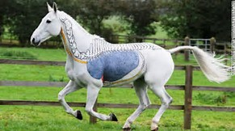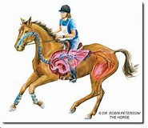

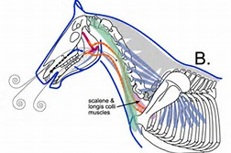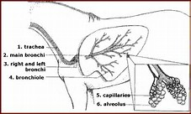

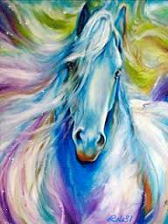 BEST BIRTHDAY WISHES ON YOUR BIRTHDAY

November

3 - Dawnay Jacobs
- Travis Jackson
5 - Jenny Firth
6 - Tarryn Higgs
7 - Samantha Gilson
- Tony Higgs
- Megan Lourens
8 - Graham Powell
- Vanessa Williams
9 - Mark Rubin
10 - Pierre Le Grange
11 - Clint Mattheus
- Carah Koekemoer
12 - Ian Gourly
- Rickus Cilliers
16 - Daniel Haldane
17 - Tyler Dell
- Amy Cocker
18 - Christopher Newton
20 - Peter Choice
- Candice Odell
22 - Shaun Wheeler
23 - Bruce Maclarty
25 - Hannah Lohry
26 - Mark Arnold
27 - Ty Van Onselen
30 - Sydney Viljoen
- Lauren Heynes

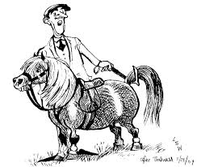

HORSES, etc

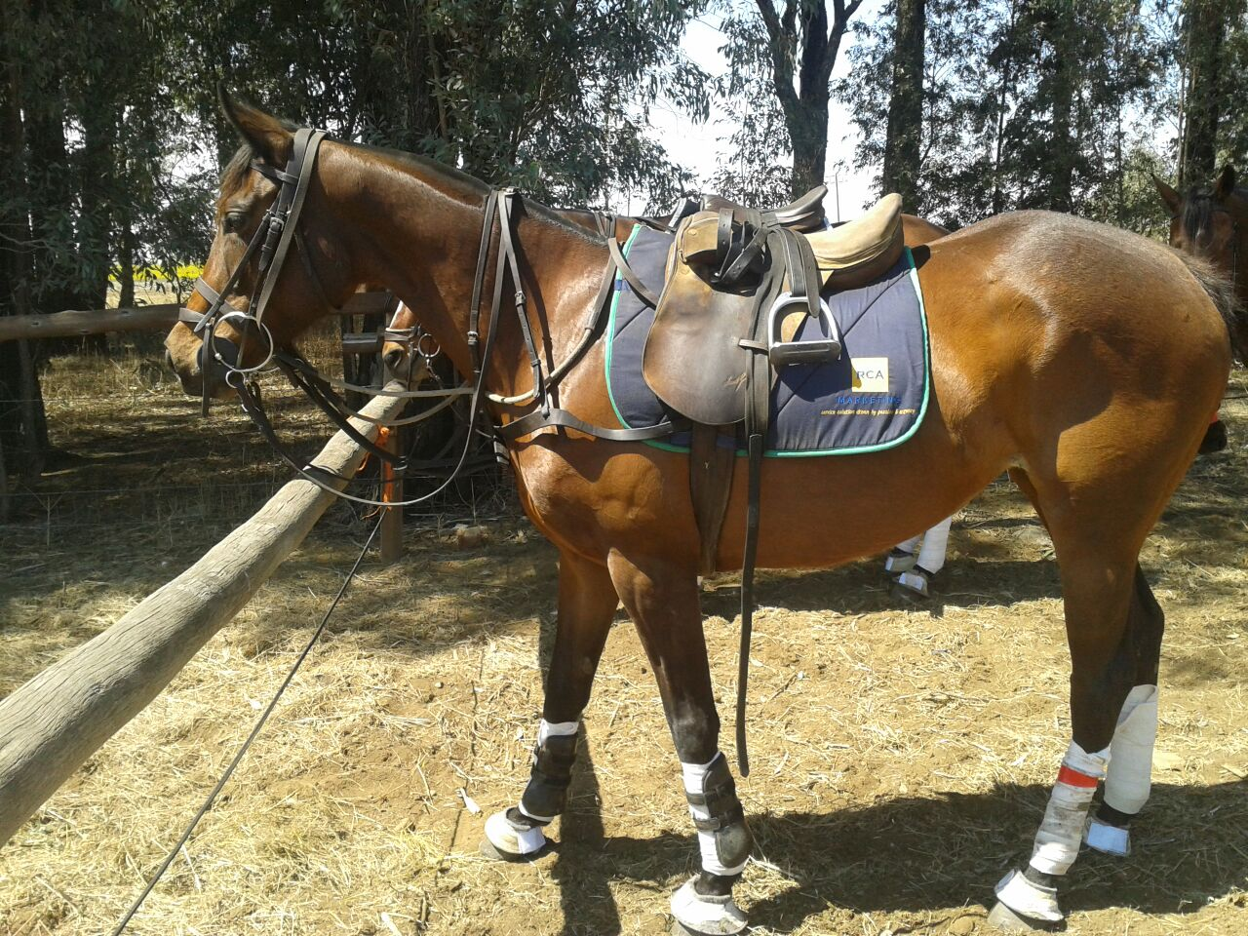

SKY BLUE STAR – 6 YEAR OLD T/B MARE, 15.1, CLEAN. HAS PLAYED QUADRANGULAR LADIES FOR UK AGAINST SA AND USA. ALSO HAS PLAYED A BIT OF POLO. SIRE ANTONIUS PIUS. VERY HANDY WILL SUIT LADY OR EXPERIENCED JUNIOR. CAN PLAY ALL THREE POSITIONS.
CONTACT ASHLEIGH SHAW 0748916657

STABLES TO LEASE
Opening in October in Eston. Loads of grazing.
Email : stables2018@gmail.com
