
The ninth chukka
September 2015

CONTENTS: CONTACT US:
Umpire Whistle
SA Champs results pasa@futurenet.co.za
Birthday Wishes
Horses for Sale

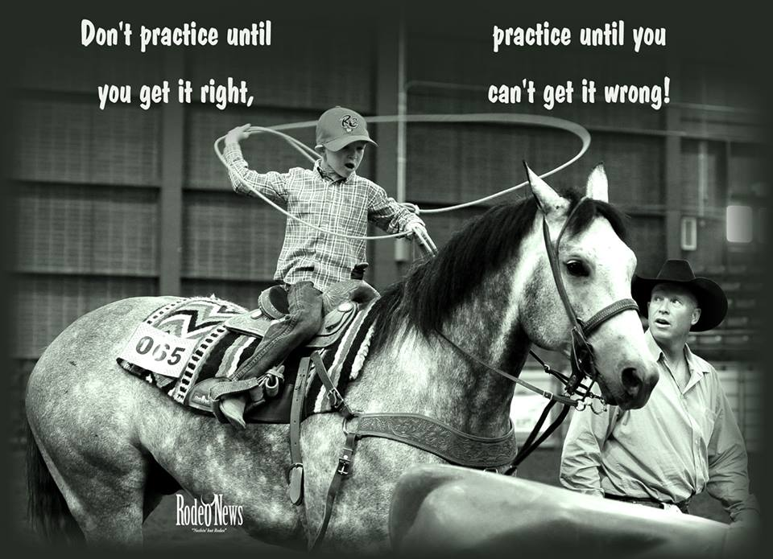

 UMPIRE’S WHISTLE

Umpires Whistle September 2015
Hi everyone, well after the hustle and bustle of the World Cup we went straight into a polocrosse packed month with I.P.T in Paddock followed by SA Champs in Richmond.
Thanks to all the umpires who attended the umpires meeting in Paddock it was great, however I wish I could say the same for SA Champs, in total only four umpires attended the meeting, only four umpires guys? Umpires meetings need to be taken seriously and I urge all umpires to please ensure they attended these meetings in the future. Umpiring needs to be taken seriously, we don’t arrive late for the games we play so then why do we arrive late for the games we umpire?
Another issue that always raises its head is umpires not umpiring in their white jeans and riding boots, please guys can we make sure this simple rule is followed.
Hopefully each player has a copy of the rule book and during the off season I really hope that everyone will get a chance to read through it and if anyone has any questions or if any provincial umpire requires any assistance please do not hesitate to contact me.
Going forward into the 2016 season I urge all Provincial Umpires to ensure that their relevant club umpires get their clubs to write the umpires tests so that we can see the level of knowledge of each player. There is nothing stopping us having umpiring clinics where the rules can be explained thoroughly and then practical training can be given.
I hope everyone enjoys the last few tournaments of the year and a well-deserved rest at the end.

Andrew Human
Acting Chief Umpire



DON’T FORGET TO CHECK OUT THE PASA WEBSITE AND KEEP UP TO DATE WITH WHAT’S HAPPENING.
WWW.POLOCROSSE.CO.ZA
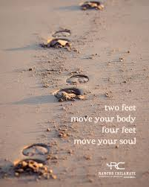

SA Champs Trophies 2015

A Division Championship Channey Cup NYATI B
A Division Handicap Mortimer Motors Trophy (replaced by
Allisons National Open Div trophy) RICHMOND A

B Division Championship Ivan Gifford Trophy (replaced by Mascor trophy) UMVOTI A
B Division Handicap Gromor Tray KENTUCKY A

C Division Championship Kyalami Floating Trophy EAST LONDON A
C Division Handicap Kathleen Young Trophy RICHMOND D

D Division Championship Gromor Trophy (replaced by pasa trophy) HILTON C
D Division Handicap Doc Sinclair Trophy (none) UMHLALI A

E Division Championship Curtis Cup MOOI RIVER C
E Division Handicap Dorita Neidman Trophy (none) BISHOPSTOWE D

F Division Championship Allisons Saddlery Trophy
F Division Handicap Trichardt T&T Shield

Robin Sparks Memorial Trophy Horse & Rider JAN ALBERT STEENKAMP

Paul Oldfield Memorial Trophy Most Worthy No.3 IAN STANELY

Hullett Aluminium Trophy Player Development HILTON

Robbie Odell Memorial Most goals scored in a
chukka in A Division CALEY HIGGS

Farmers Weekly Umpire of the Year PATRICK O’SULLIVAN

George Rautenbach Memorial Player of the Year JEAN HACKLAND

Bomber Nel Trophies
Best Jnr/Horse JOHN RAE AND MISCHIEF
Ginny Herbert ASHLEIGH SHAW
Golden Pony CALEY HIGGS - SQUAW



SEPTEMBER

1 - Jacolien Brits
2 - Thembi Madonsela
3 - Phephe Buthelezi
4 - Caroline Minnaar
5 - Sebastian King
6 - Charlette Bekker
- Brent Von Benecke
- Robert Anderson
- Travis Timm
8 - Edric Badenhorst
- Lance Hosking
10 - Theunis Linde
12 - Lauren Kuhn
13 - Daniel Bunge
16 - Codi Campbell
- Dane Csaszar
- Josh Hallé
20 - Jessica Heaver
- Mark Starker
22 - Andrew Human
- Jani Peel
23 - Maverick Gillespie
25 - Lita Timm
28 - Tayla Mansfield
- Sandy Fortmann
- Henk Dafel
- Jannie Steenkamp
30 - Charles Hall
- Michelle Witthoft



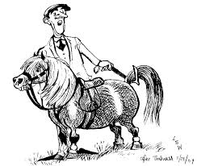

HORSES, etc

HOLLEY : 12 year old Bay mare, 15.3hh. This big strong mare has a massive heart and is great as a 1, 2 or 3. She has a lot of experience, sad sale due to owner giving up riding. Would suite experienced rider. R15 000.00
Contact: Priscilla Dent at tambotitrading@gmail.com

Marinda Miles is looking to buy a Kilmore Stock Saddle, please contact her on 0832634387, if you can be of assistance.

