

Action-Packed Land Rover Durban High Goal Polocrosse Tournament Thrills Crowds

Spectators at the third annual Land Rover Durban High Goal Polocrosse Tournament were treated to a perfect weekend of warm winter sunshine, blue skies and world-class equestrian action at the province’s premier venue, the Shongweni Polocrosse Club.

Hundreds of spectators were treated to fast-paced polocrosse exploits between Friday 22nd and Sunday 24th June from the country’s and some of the world’s highest ranked players most of whom will be playing in the upcoming 2019 World Cup.

The Land Rover Durban High Goal featured eight teams consisting of the highest ranked players, who took part in the prestigious tournament which was the perfect platform to compete against each other at the highest level ahead of next year’s World Cup in Australia. South Africa are the defending World Cup champions.

Polocrosse matches are played in three levels - low goal, medium goal and high goal – depending on a polocrosse team’s total of each player’s handicap. The term ‘goal’ does not refer to how many goals the player scores in a match, but rather indicates the player’s value to the team.

Being a High Goal tournament, each team consisted of six players and an option to buy a wild card as their seventh player, thus adding a mystery to the winning team.

The Rokwil men’s team broke team Land Rover’s two-year winning streak, when they beat team Kego 32-24 in an exhilarating finale. Second place went to TWK Agri, third place to Kego and fourth place to Land Rover.

The Most Valuable Men’s Player Award went to James Hackland of team Rokwil. South African team captain Jannie Steenkamp won the Best No. 1 Men’s Player Award, with Best No. 2 John Rae (South Africa) and Travis Timm (South Africa) as Best No. 3 for the tournament.

In the final ladies game for the day, team Roski lost by one point to Land Rover Evoque with a score 23-22. However, in the overall standings following three days of play, team Roski took first place ahead of team Evoque, with teams Meru Moru in third and team Equest in fourth place.

The Best No.1 Ladies Player went to Australian Lucy Grills with South Africa’s Karen Cocker as Best No.2 and Australia’s Sandy Weston as Best No.3. The Most Valuable Ladies Player Award was won by Caley Higgs.

The Golden Pony Award in the women’s category was won by Rio, ridden by Natalie MacLarty. In the men’s category, the Golden Pony Award was won by Miss Disco, ridden by James Hackland.

Over the three-day tournament, there were eight teams, fifty-six players and about a hundred horses which put on a spectacular world-class performance.

/ENDS

Please see below for images, high resolution are available on request.
Please ensure that the photographer: Shannon Gilson is credited. Images are complimentary for media use, provided the correct photo credit is used.

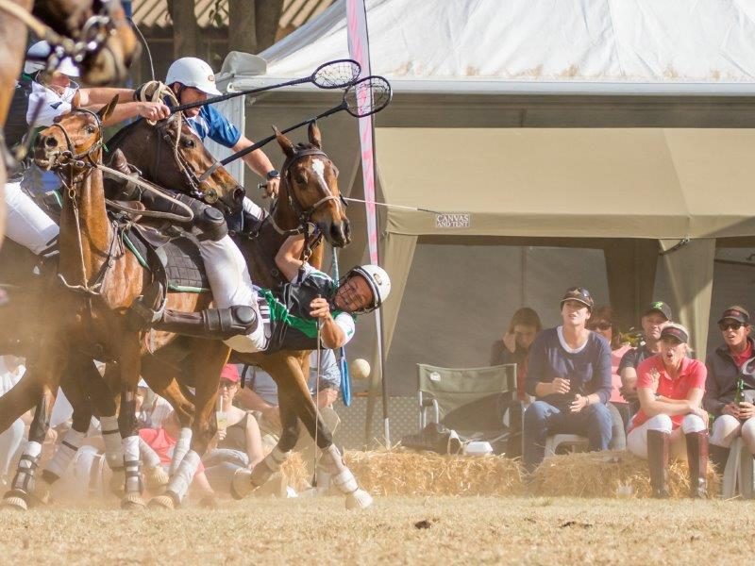
Stefan Harris.

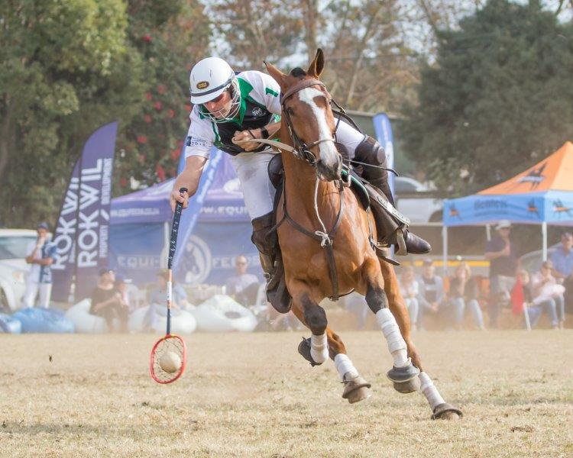
Jannie Steenkamp.

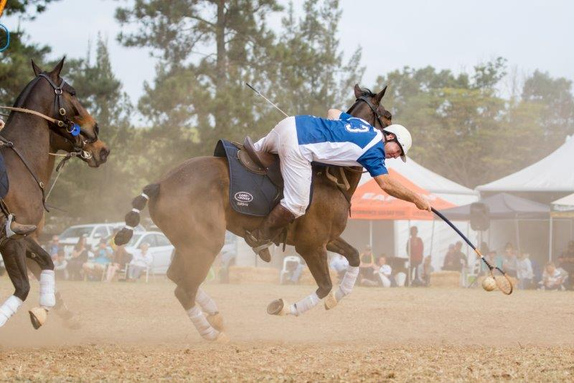
Gavin Cocker.

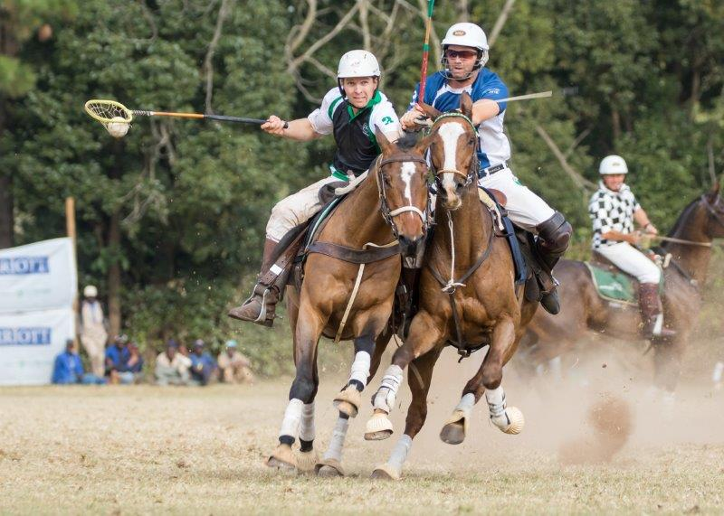
Will Weston and Graham Maclarty.

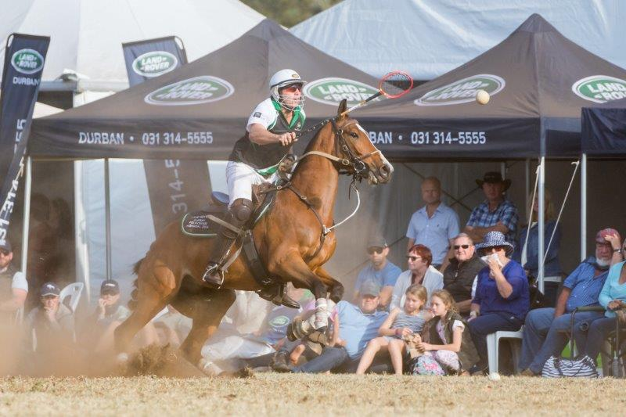
Jannie Steenkamp.

Issued on behalf of:
Land Rover Durban High Goal

Disseminated by:
Olivia Jones Communications

For more information please contact:
Olivia Jones Communications
Cell: 083 653 1720
Email: media@oliviajones.co.za

Unsubscribe
This message was sent to pasa@futurenet.co.za from media@oliviajones.co.za
Olivia Jones Communications
19 Norfolk Road Berea
Durban, KZN 4001, South Africa
- - - - - - - - - - - - - - - - - - - - - - - - - - - - - - -


